# Lab 01 - Simulate a Repository Migration from Azure DevOps to GitHub Enterprise Cloud using GitHub CLI and GEI

In this lab, you will learn how to **simulate and validate the migration** of a source code repository from **Azure DevOps (ADO)** to **GitHub Enterprise Cloud (GEC)** using the **GitHub CLI**, the **GitHub Enterprise Importer (GEI)**, and the **ado2gh CLI extension**.  
This involves both a **dry-run** and a **real migration**, using PATs and validated permissions to confirm readiness and ensure smooth migration of project assets.

Objective :

To simulate and validate a successful migration from **Azure DevOps** to **GitHub Enterprise Cloud** using **GitHub CLI**, **GEI**, and the **ado2gh extension**, and ensure project readiness for production migration.

**Pre-requisites**

Ensure the following before you start:

* A GitHub account with repo creation access
* Azure DevOps project and repo access
* GitHub CLI installed (https://cli.github.com)
* GitHub Enterprise Importer CLI (gh-gei) installed
* Two Personal Access Tokens (PATs):
  + **GitHub PAT** (with repo, admin:org, workflow scopes)
  + **Azure DevOps PAT** (with Code (read) and Project & Team scopes)

### Task 1 : Start GitHub Enterprise Cloud Free Trial

1. Open a browser and go to <https://github.com/enterprise/trial> and click on sign in. sign in with your GitHub account.

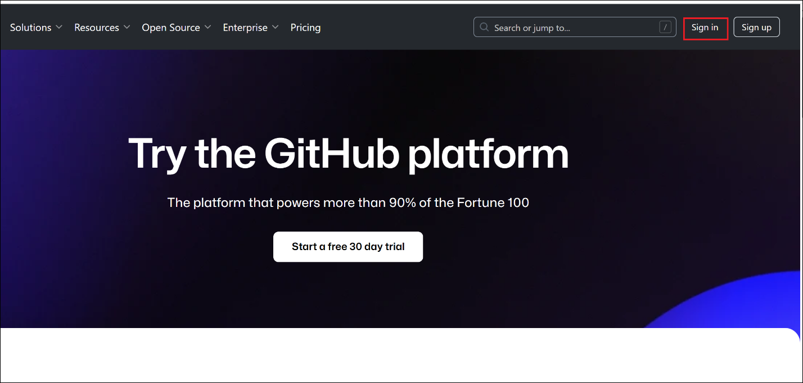

1. Click on **Start your free trial.**

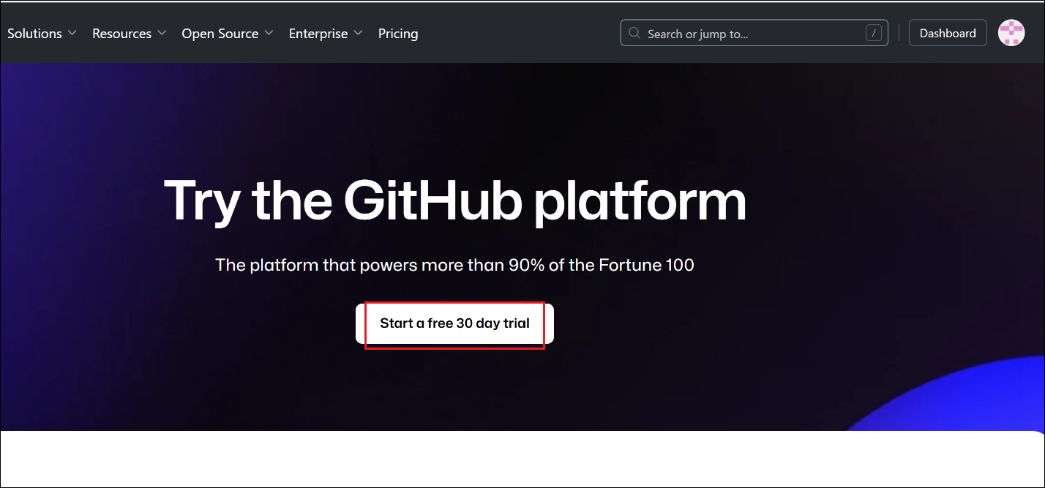

1. Click on **Get started with personal accounts.**

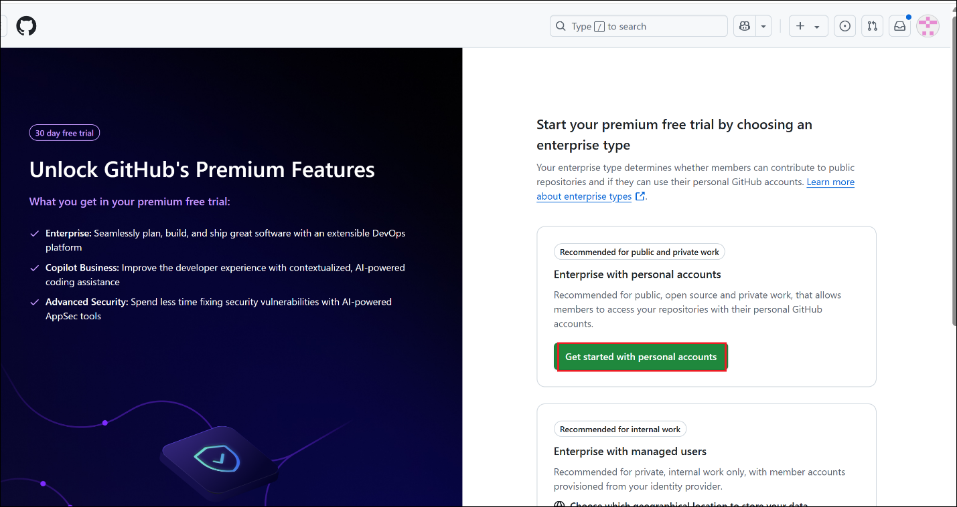

1. Enter below values and then click on **Create enterprise.**
   1. Enterprise name : **tfdevops-migr**
   2. Enterprise URL slug : tfdevops-migr
   3. Industry : education (you can select as per your requirement)
   4. Number of employees
   5. Etner Contact information
   6. Verify account
   7. Accept trial term

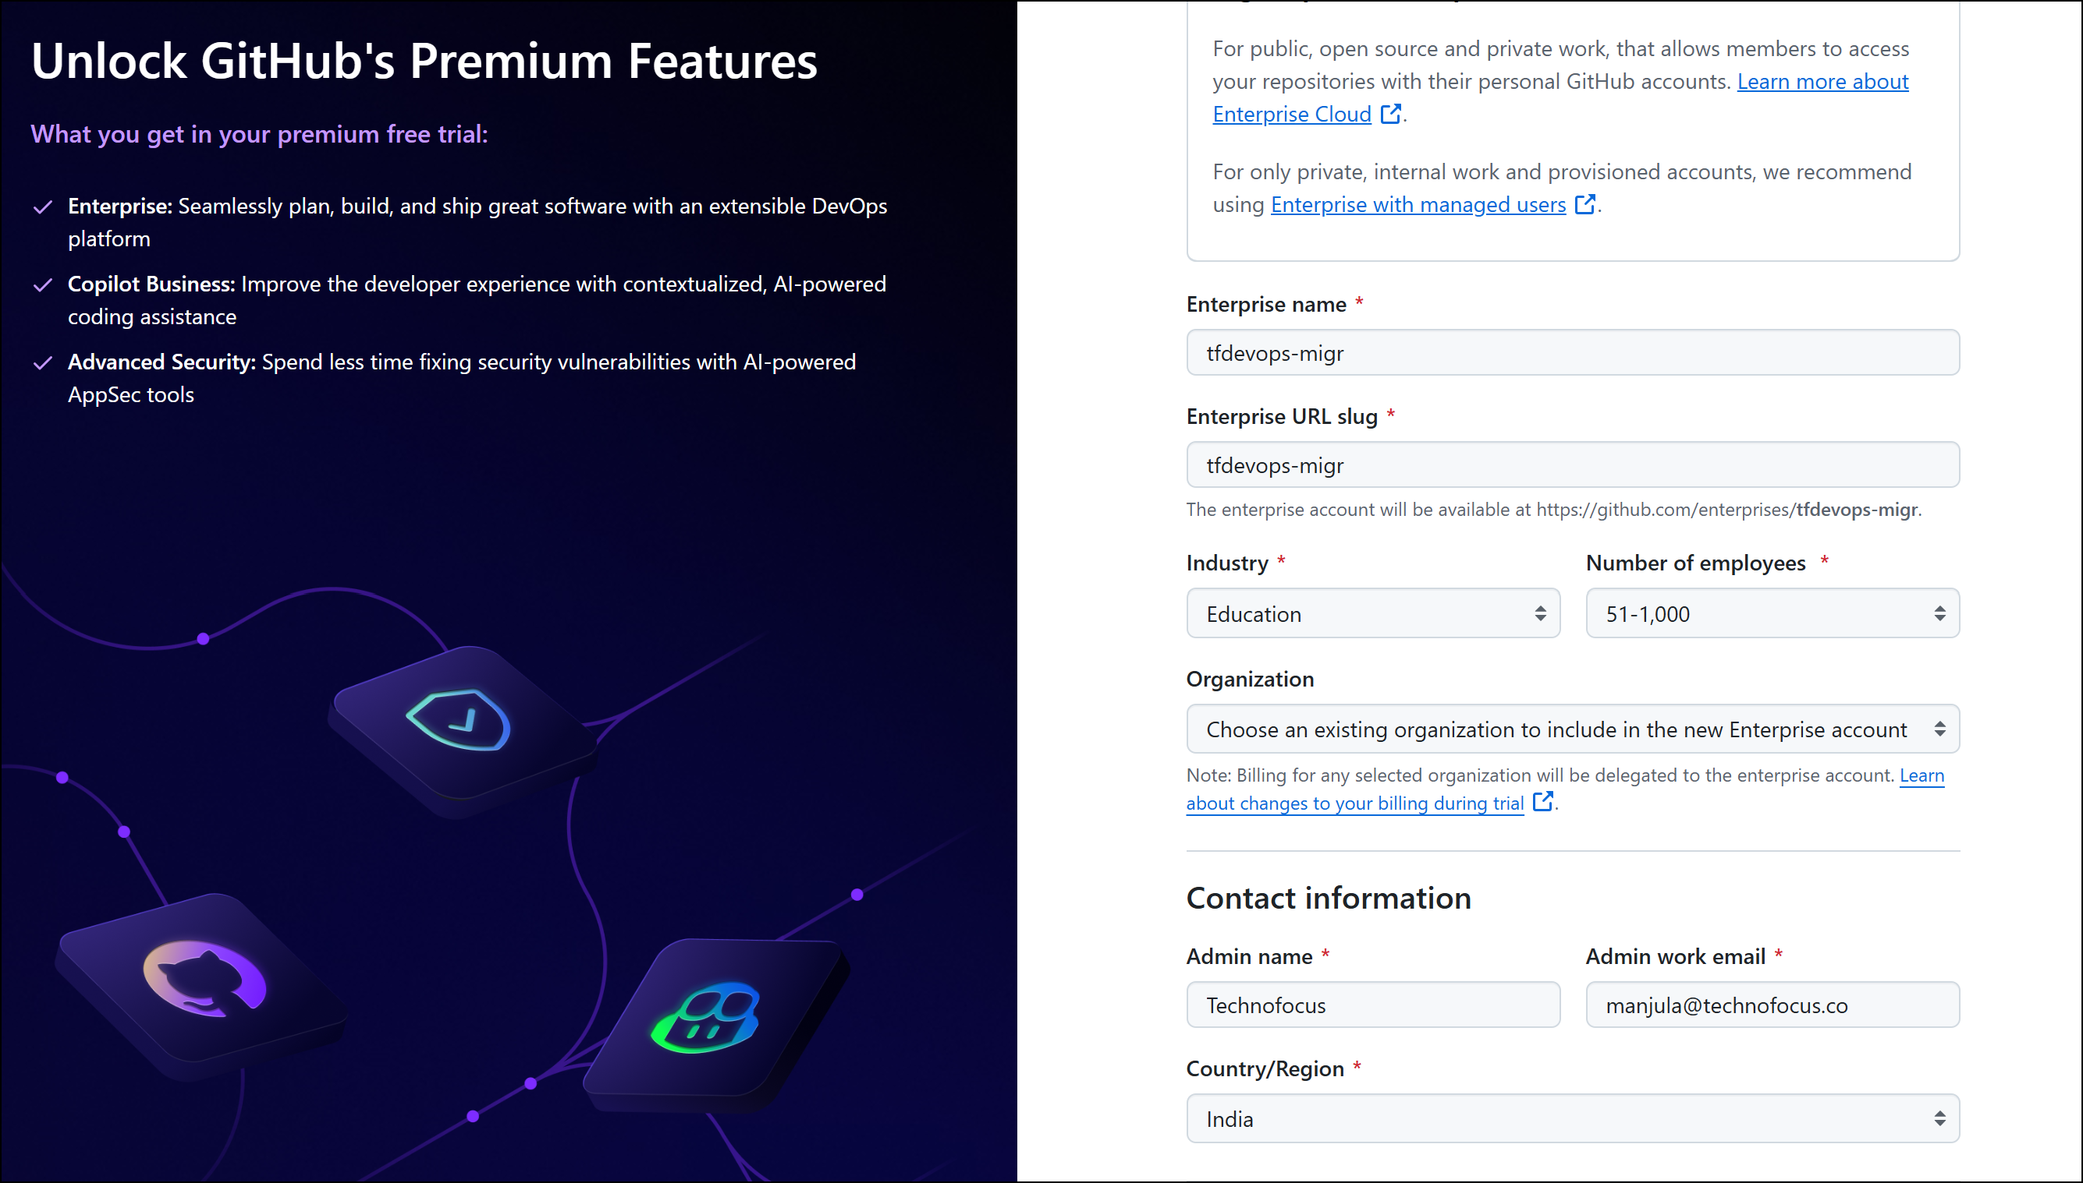

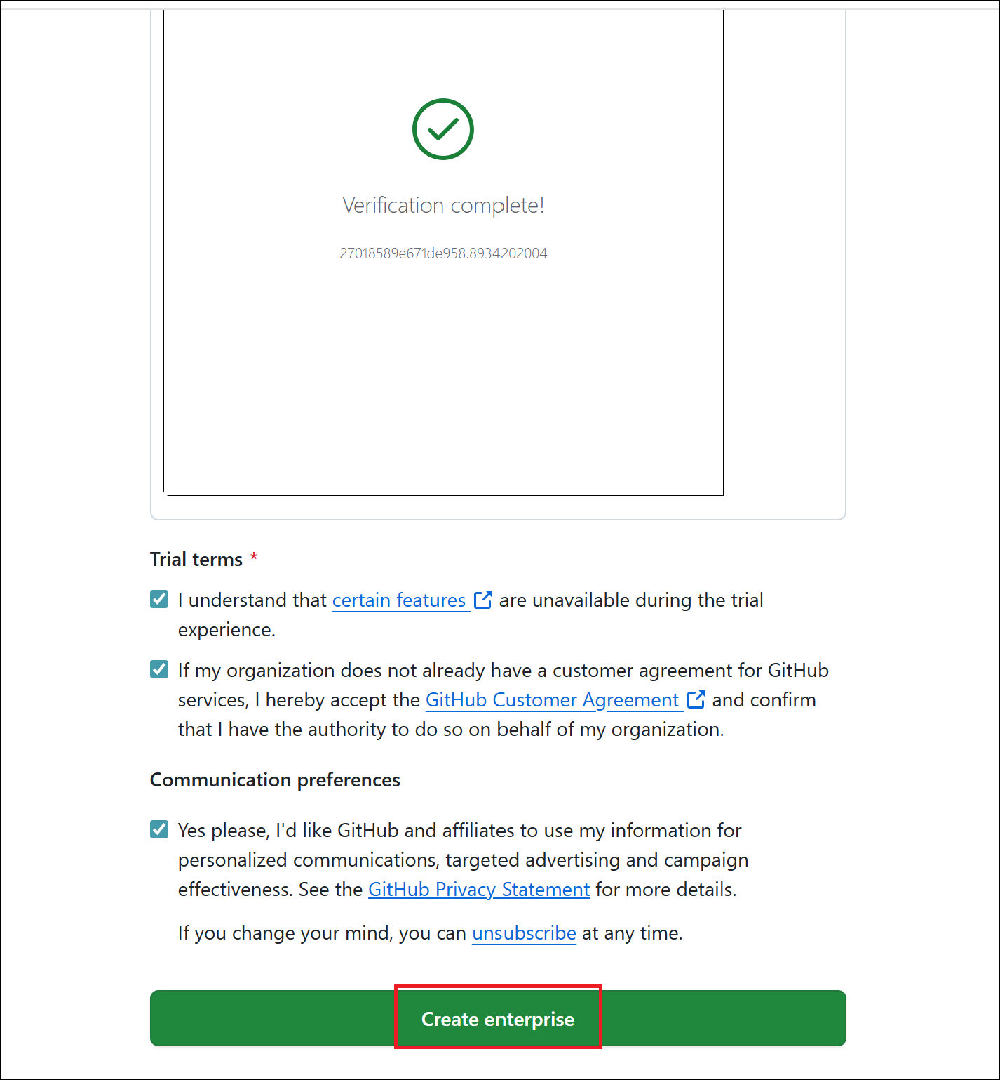

1. Click on **Skip for now** button to sip the payment method.

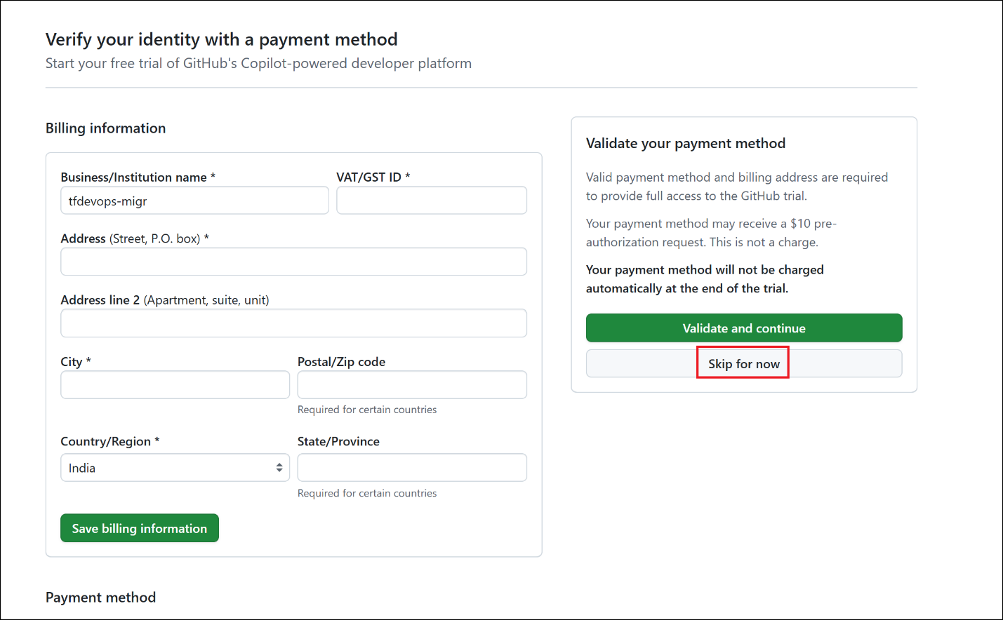

1. Etner **Organization account name :** **devopstogtihub or acme-devops-migration** and click on **Create organization and continue** button.

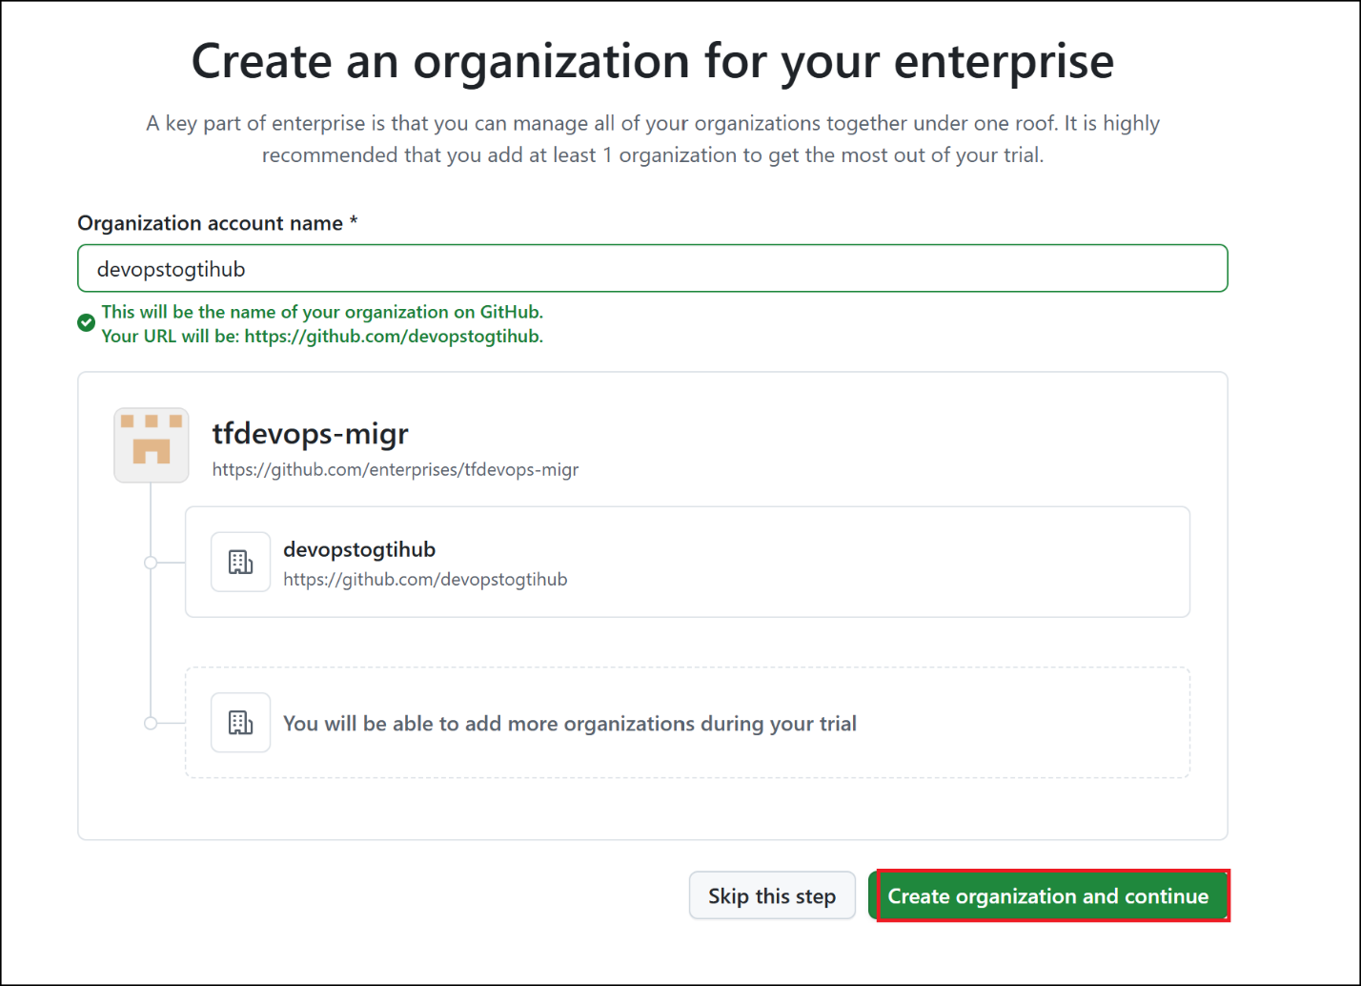

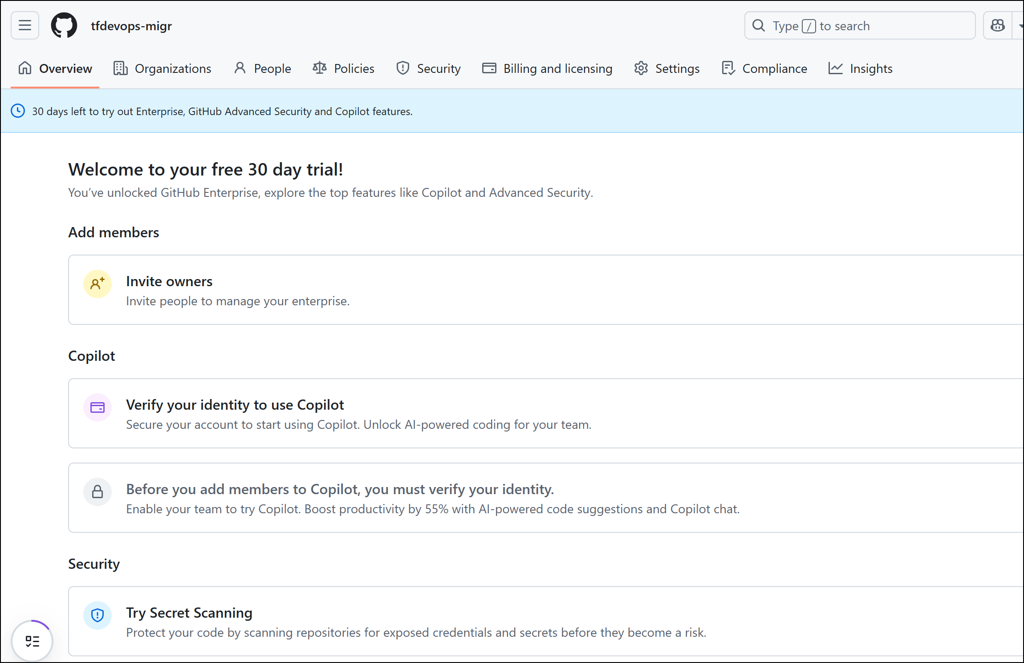

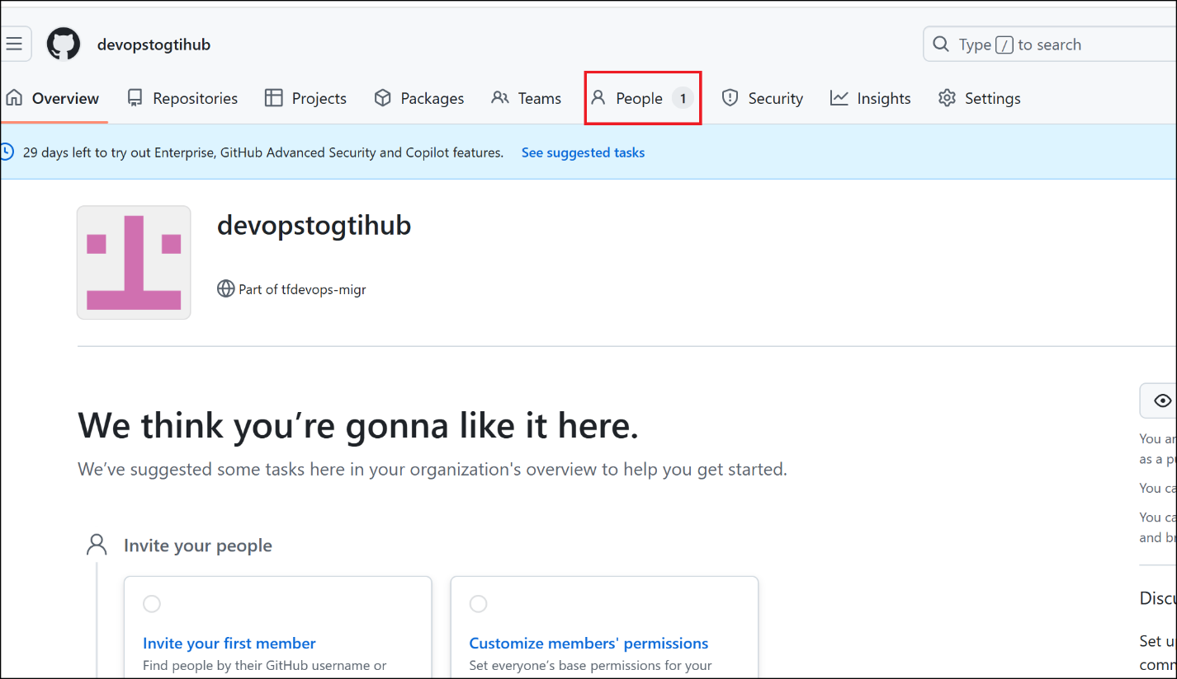

1. Click on 0 roles link under Membership column as shown in below image.

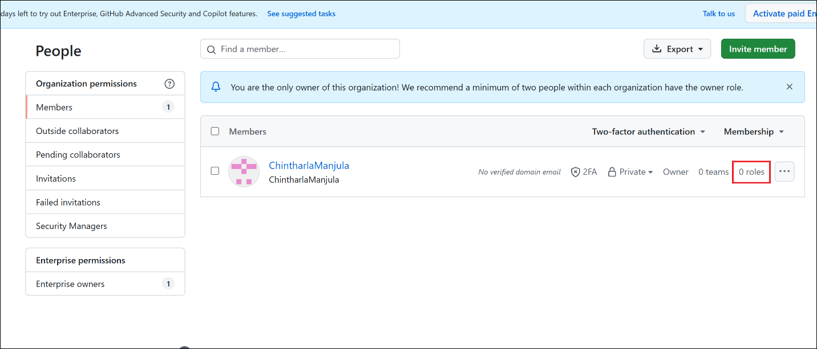

### Task 2 – Install and Authenticate GitHub CLI

1. Open Powershell as administrator.

winget install --id GitHub.cli

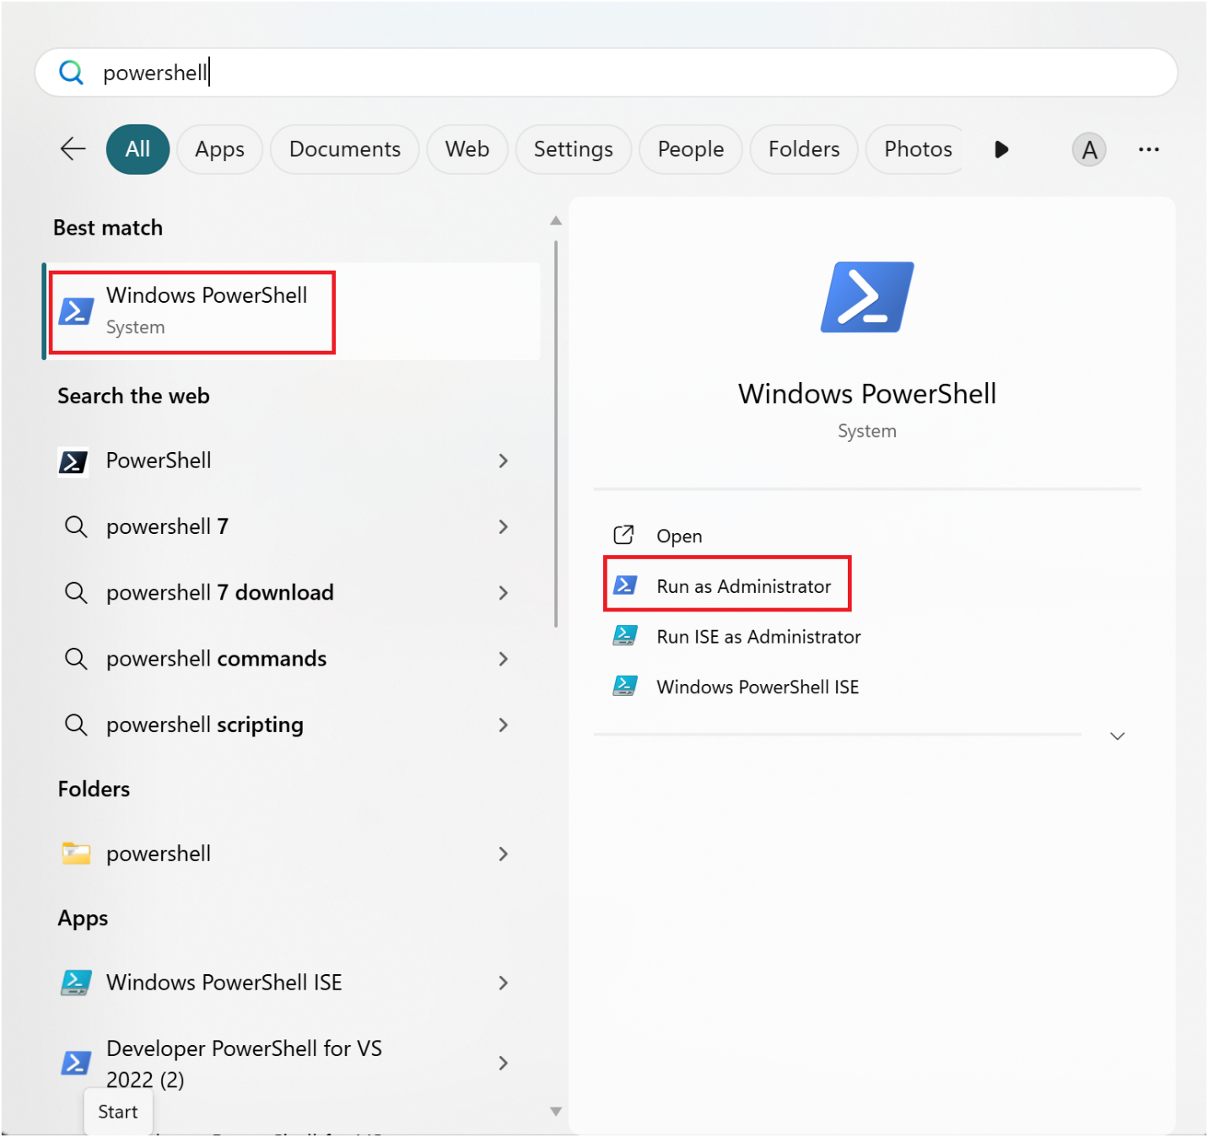

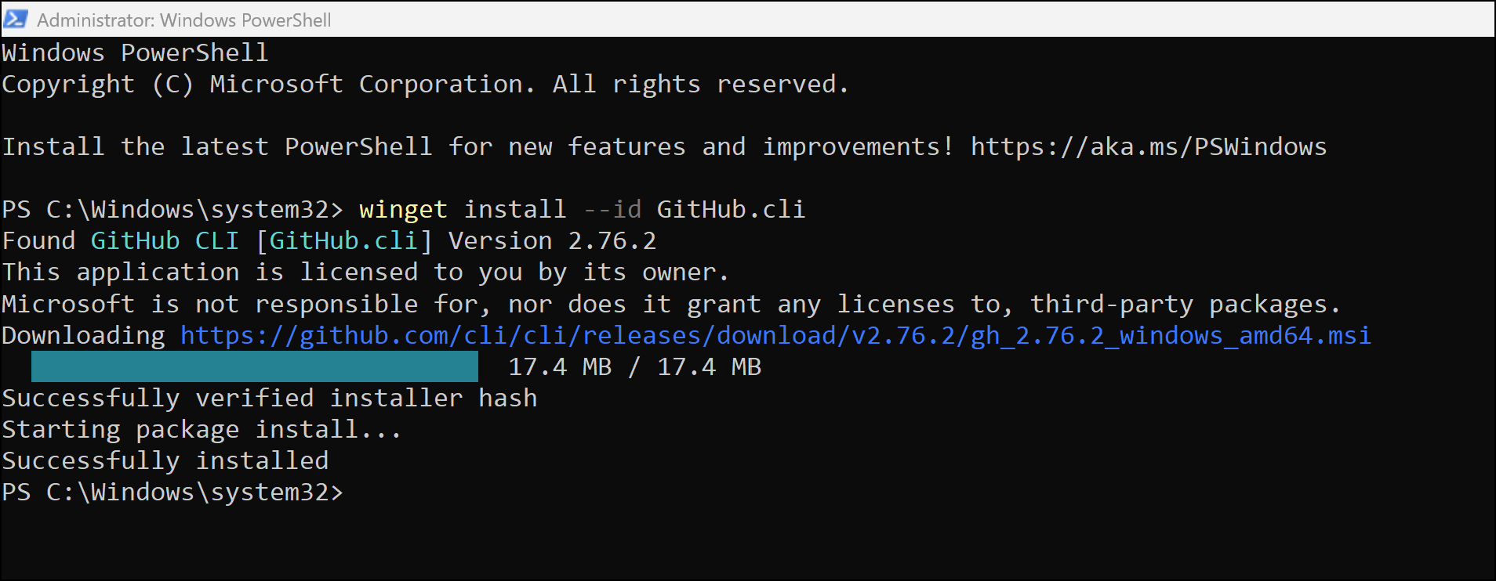

1. Close the PowerShell window.
2. By default, GitHub CLI is installed in below location. Add GitHub CLI to system PATH

C:\Program Files\GitHub CLI

1. Press **Win + S** and search for **Environment Variables** and select **Edit the system environment variables**

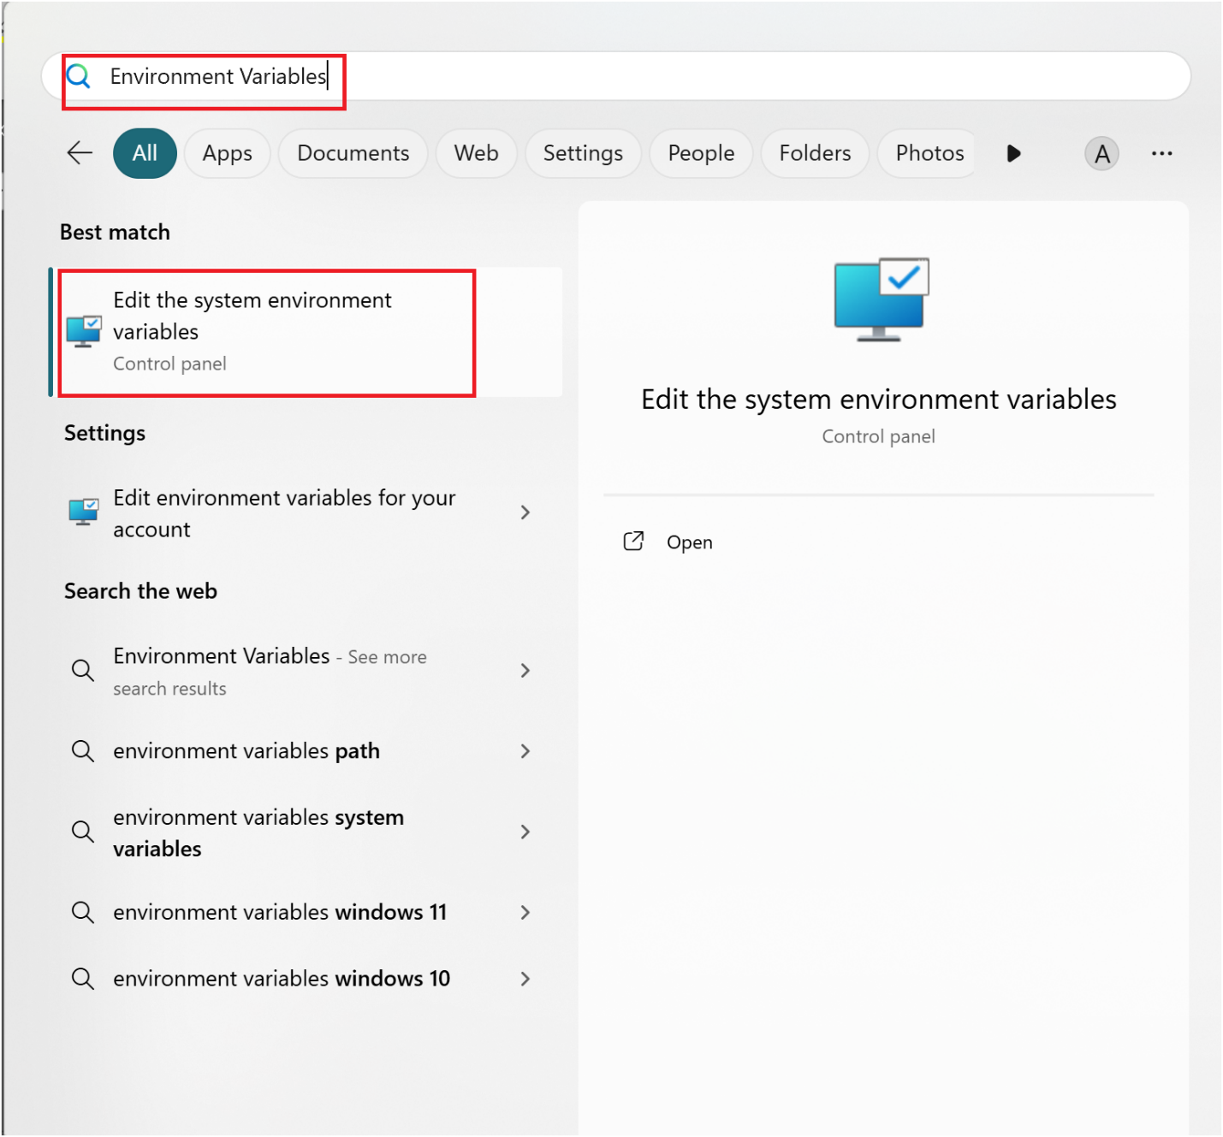

1. In the **System Properties** window, click **Environment Variables**.

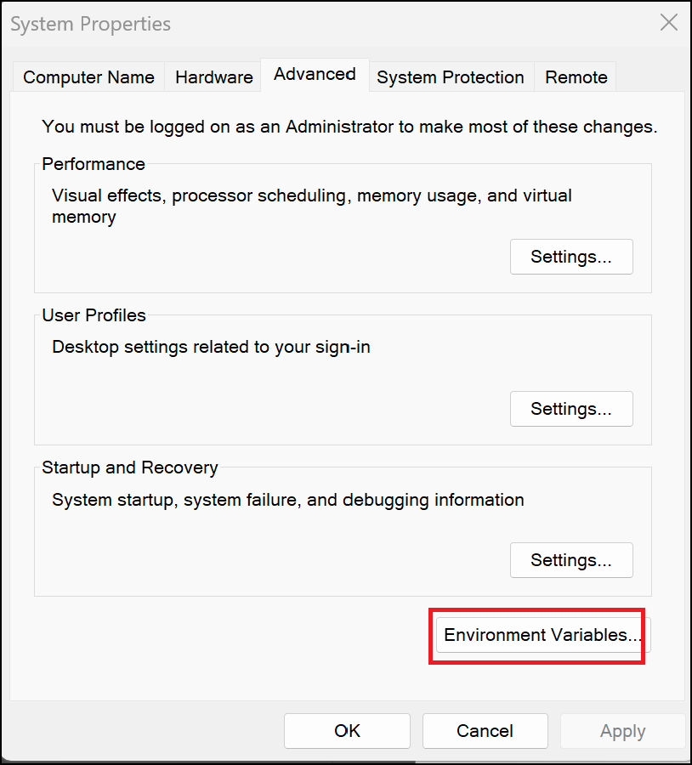

1. Under **System variables**, find and select **Path**, then click **Edit**.

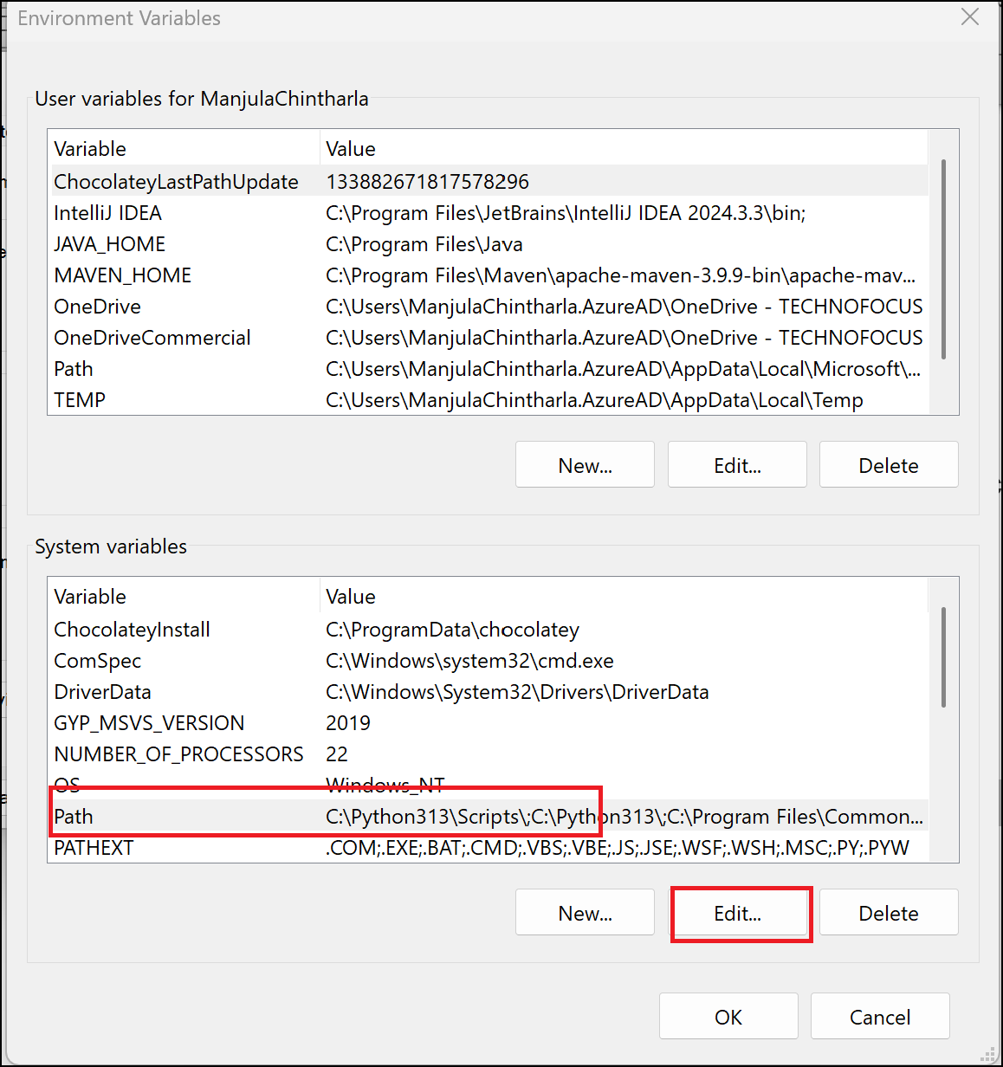

1. Click **New** and **add** GitHub CLI path and then click **OK->OK->OK**.

C:\Program Files\GitHub CLI

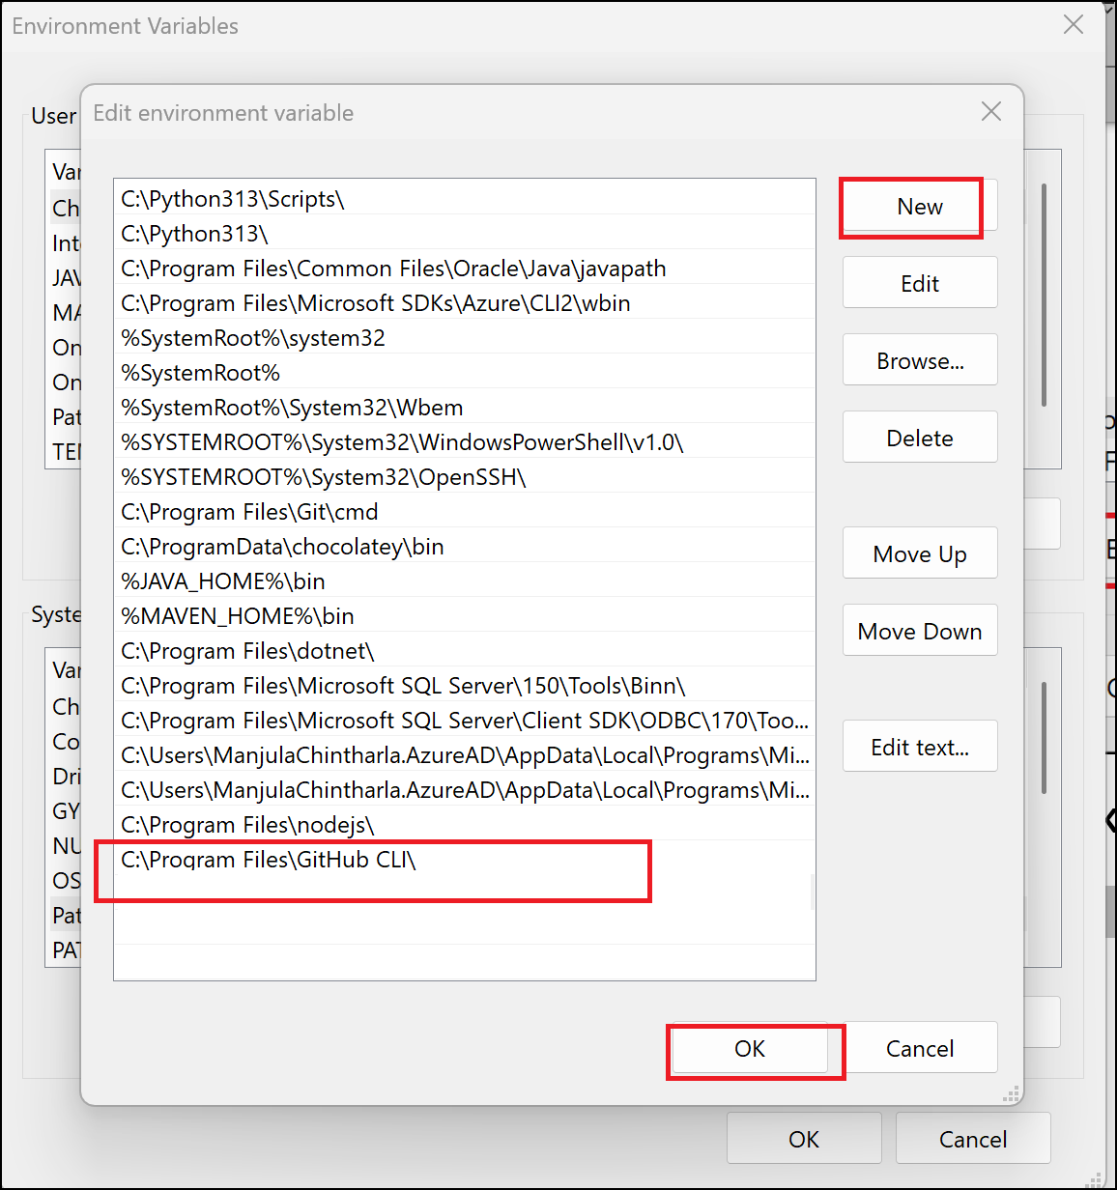

1. Restart the PowerShell and run below command login.

gh --version

gh auth login

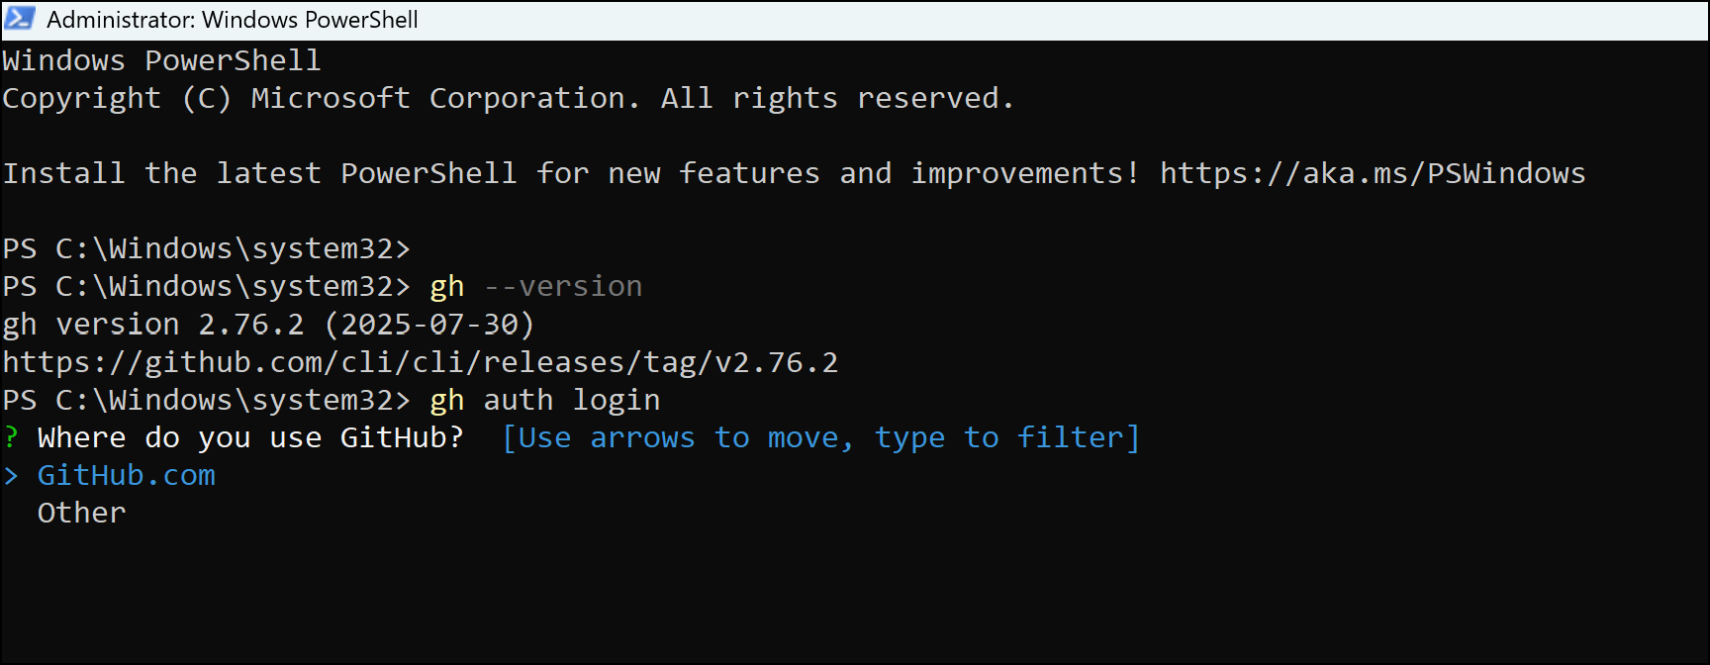

1. Follow the interactive prompts:
   1. Choose **GitHub.com**
   2. Select **HTTPS**
   3. Authenticate via browser

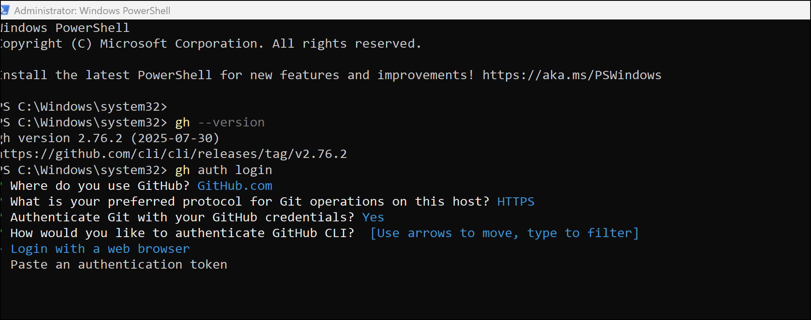

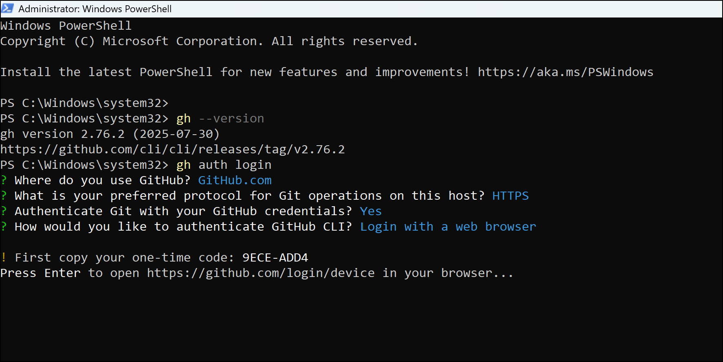

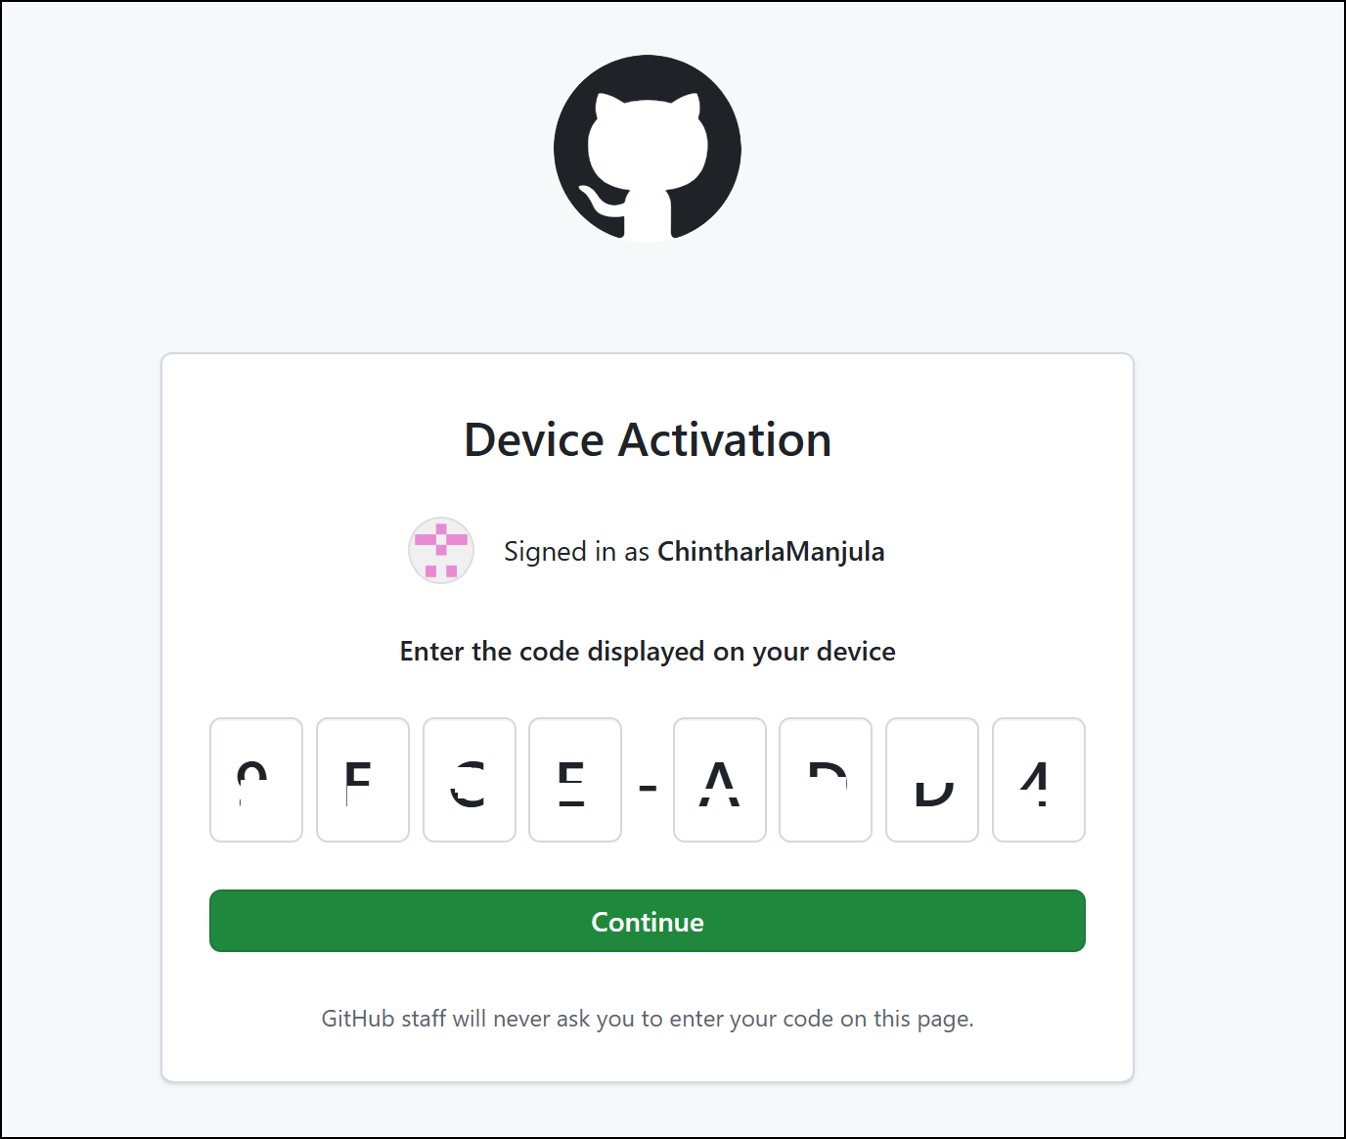

1. Click on **Authorize github** button.

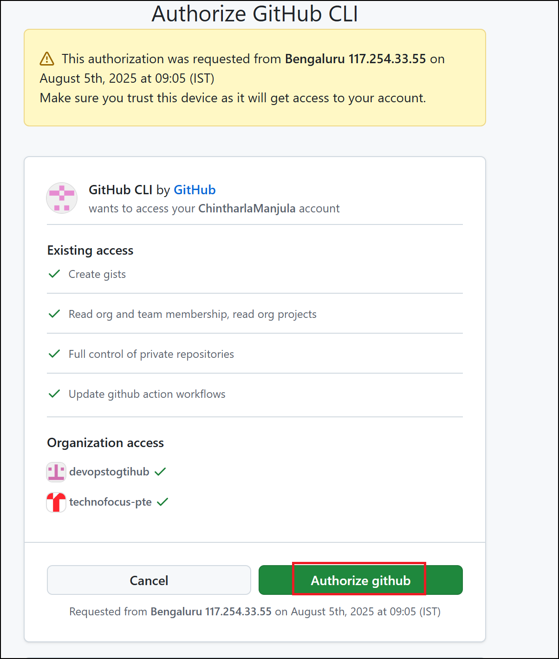

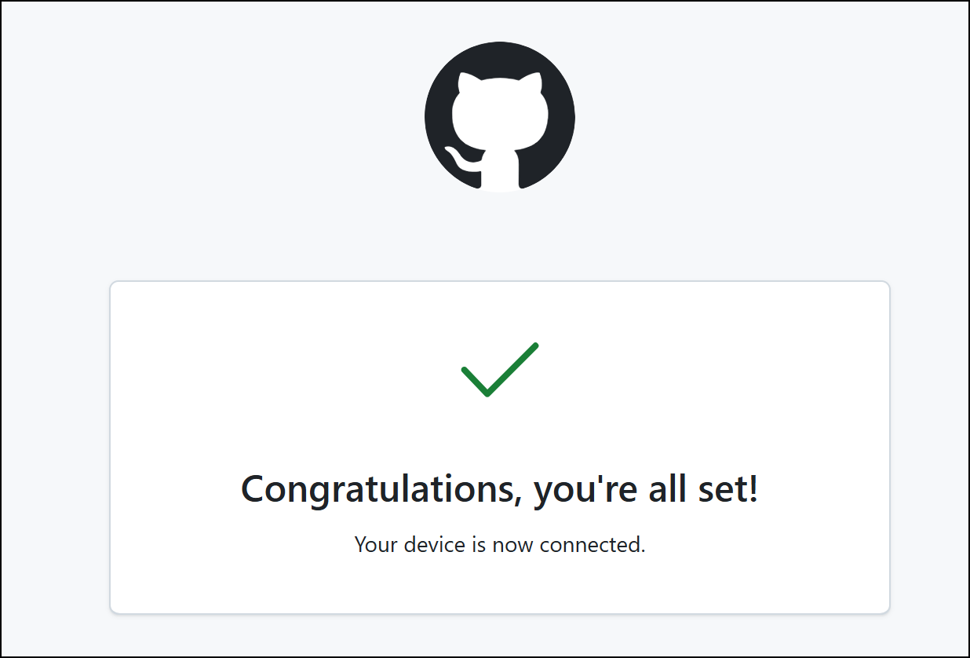

1. Switch back to PowerShell window.

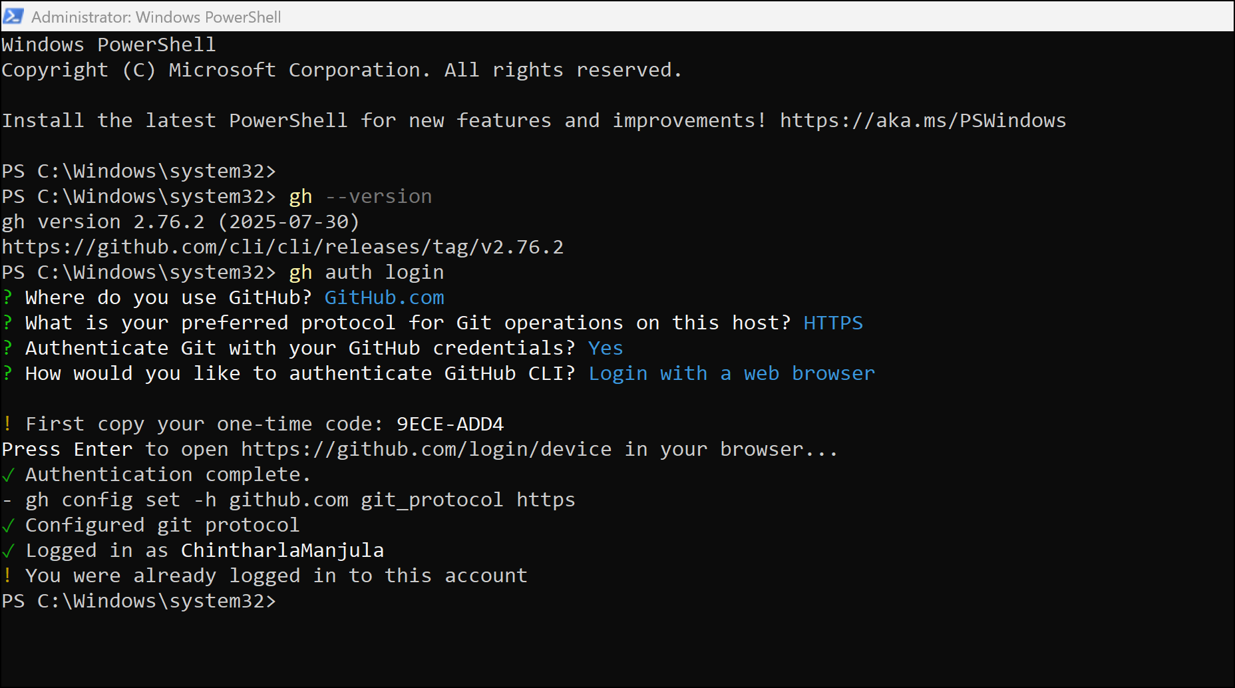

1. After login, confirm by running:

gh auth status

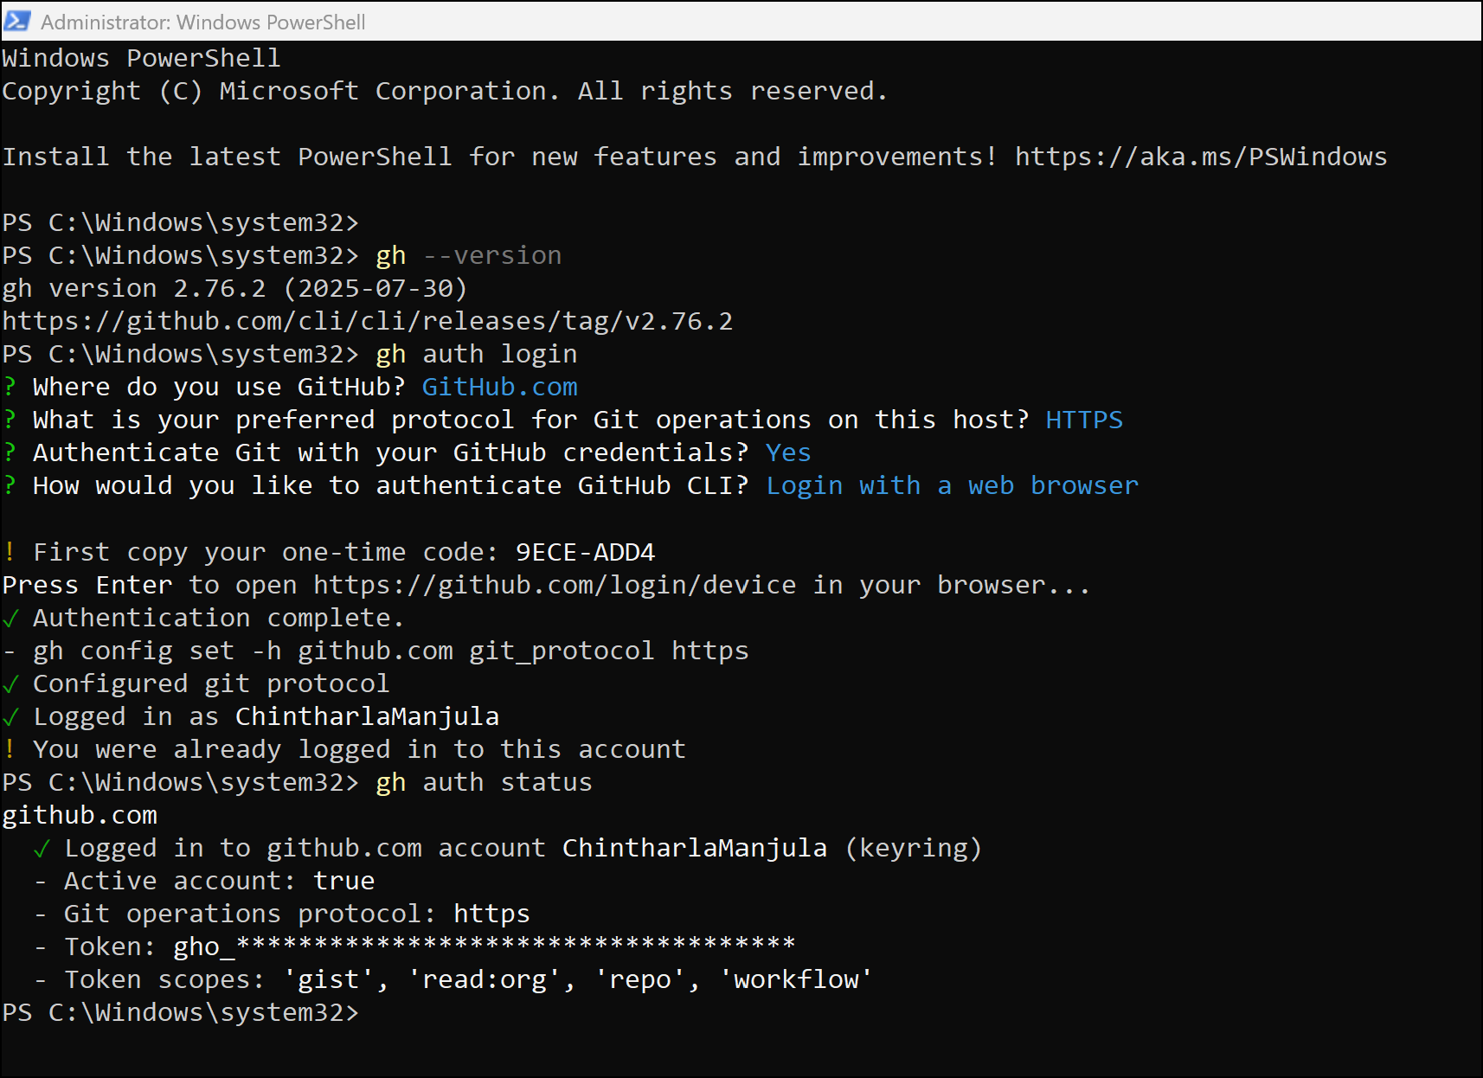

1. Verify GEC Org Admin Permissions. If you can list org repos, you’re properly authenticated and ready.Replace ORG-NAME with your organization name and then run it.

gh repo list ORG-NAME

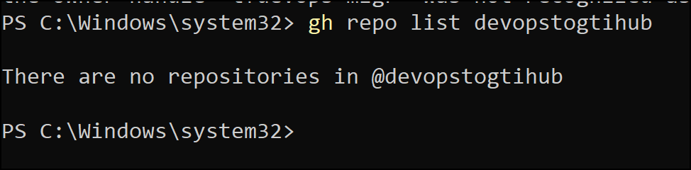

### Task 3 – Install the GEI (GitHub Enterprise Importer) Extension

1. Run below command to install GitHub Enterprise importer extension.

Gh extension install github/gh-gei 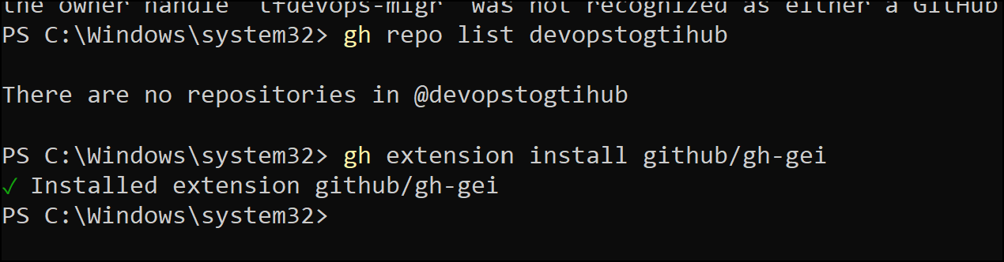

1. Confirm installation:

gh gei -h

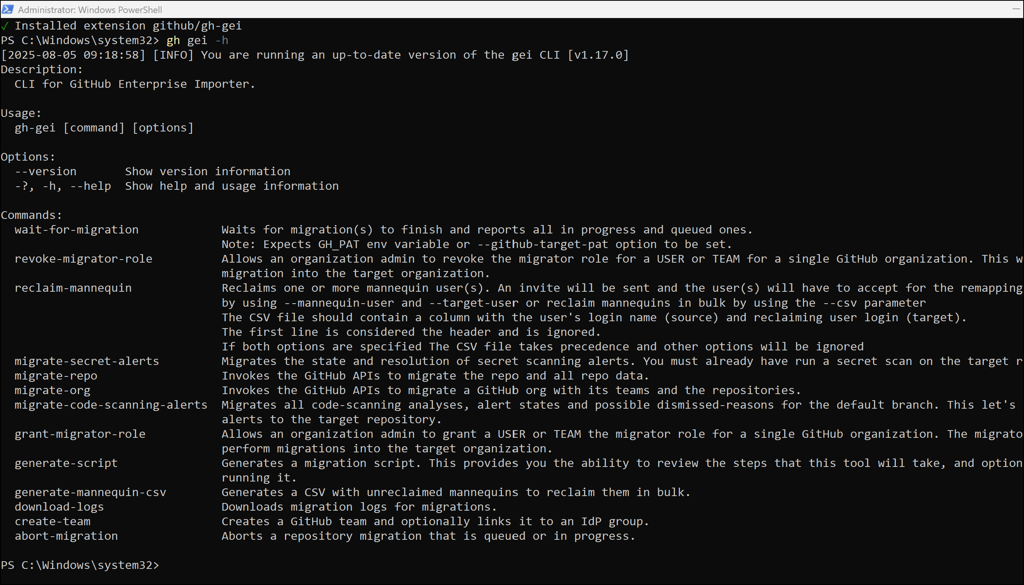

1. Verify installation:

gh gei --help

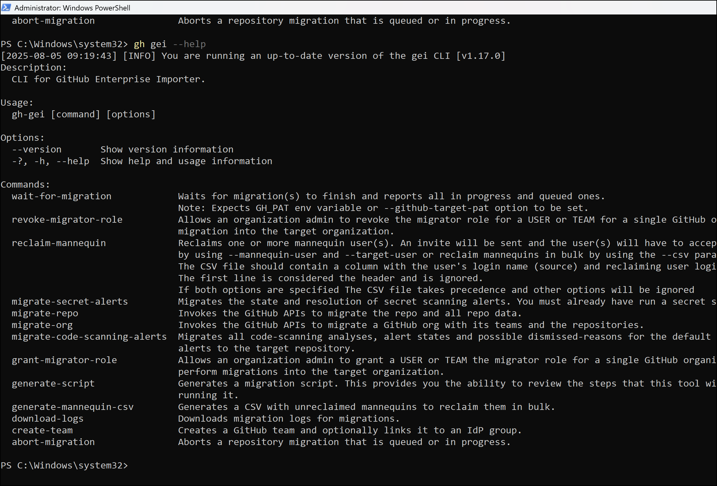

### Task 4 : Create an Azure DevOps personal access token

* 1. Create an Azure DevOps personal access token (PAT). Open a new tab in your browser and navigate to - <https://portal.azure.com/> and sign in with assigned account.
  2. Search for **Azure DevOps** and select **Azure DevOps organizations**.

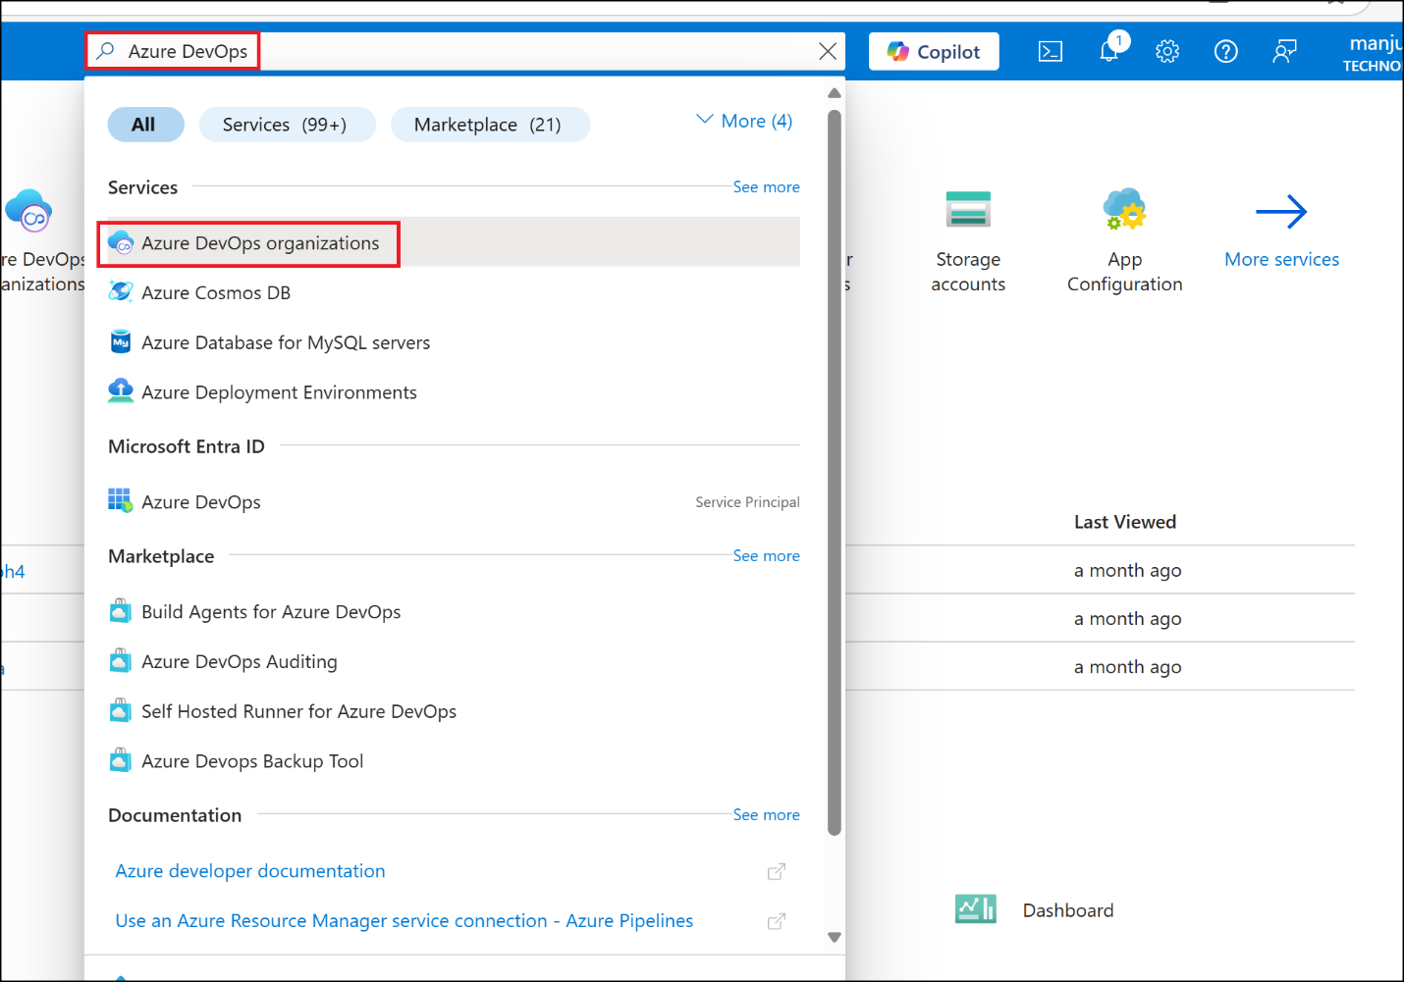

* 1. Click on **My Azure DevOps Organization** hyper link.

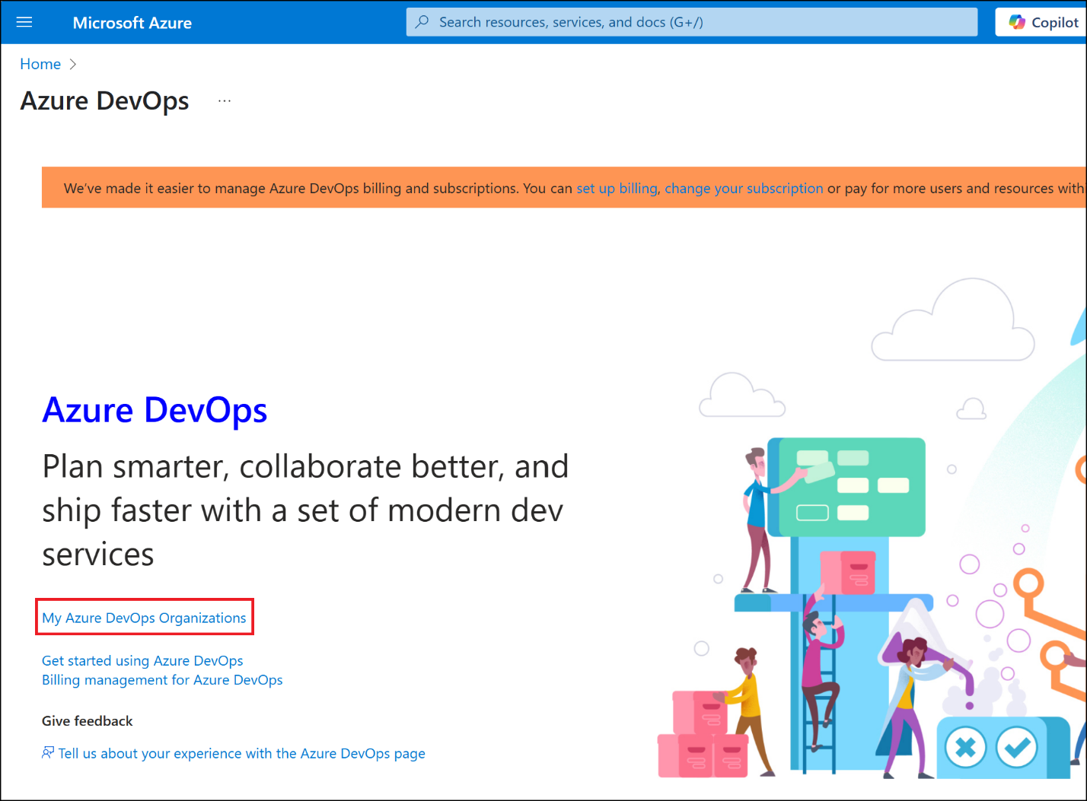

* 1. Click on **Create new organization** button.

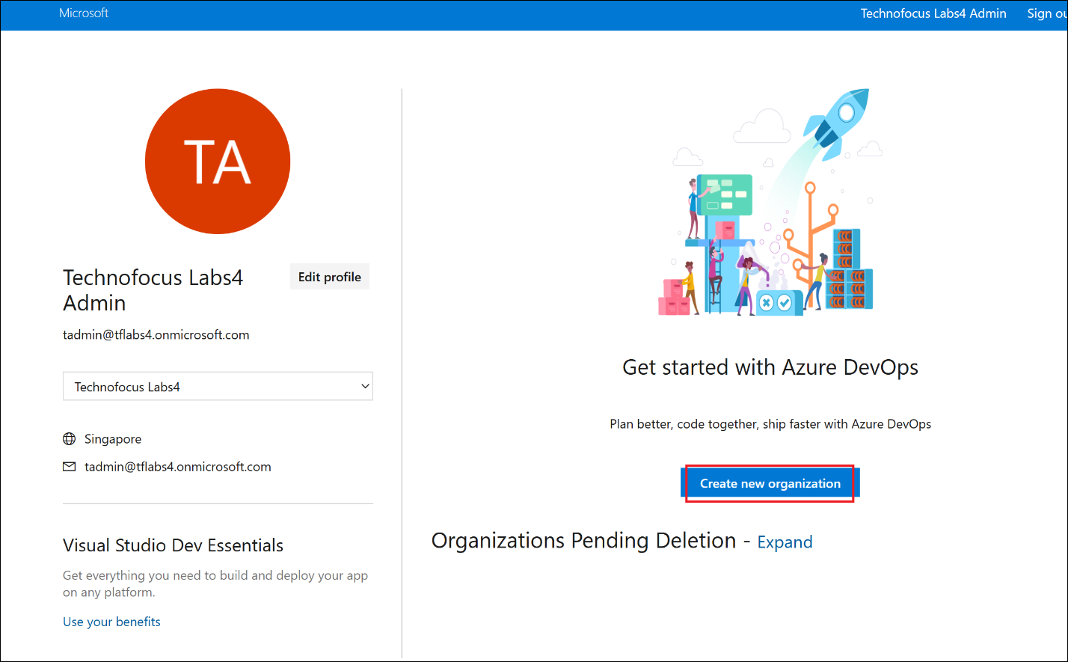

* 1. Click on **Continue**.

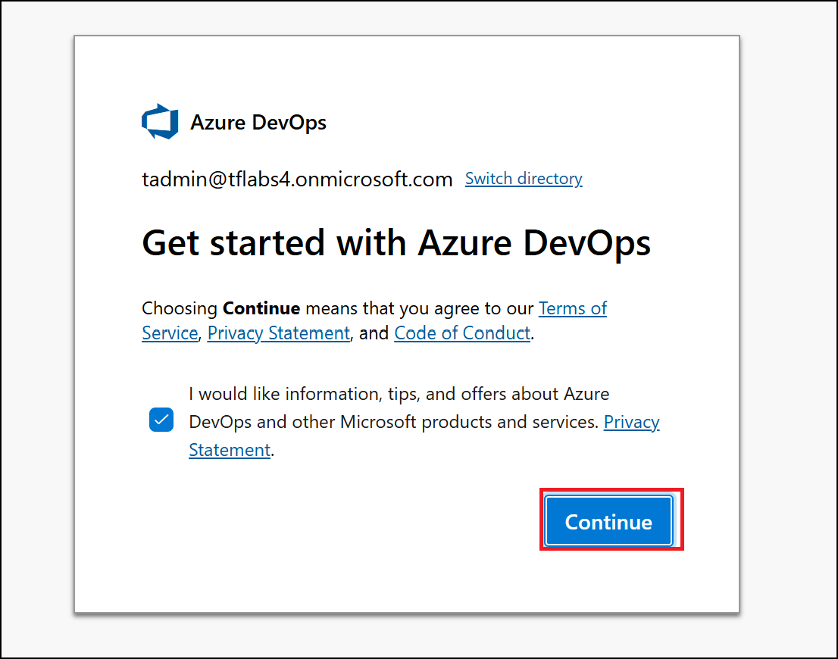

* 1. Enter the organization name as : **tffabrikamXXX** (should be unique, replace XXX with number)enter the characters shown in your screen and then click on **Continue**.

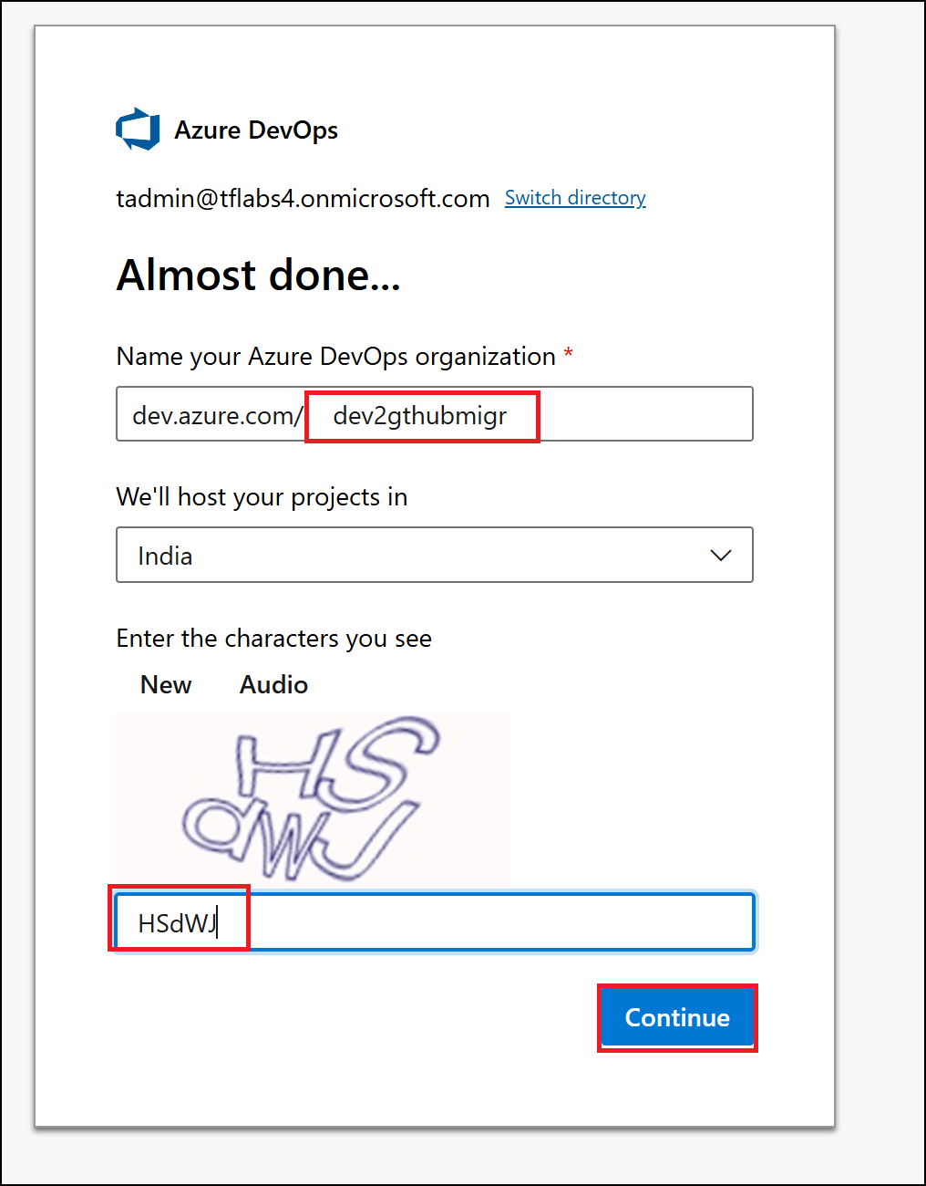

* 1. In the top right corner of the screen, click **User settings**. Click **Personal access tokens**.

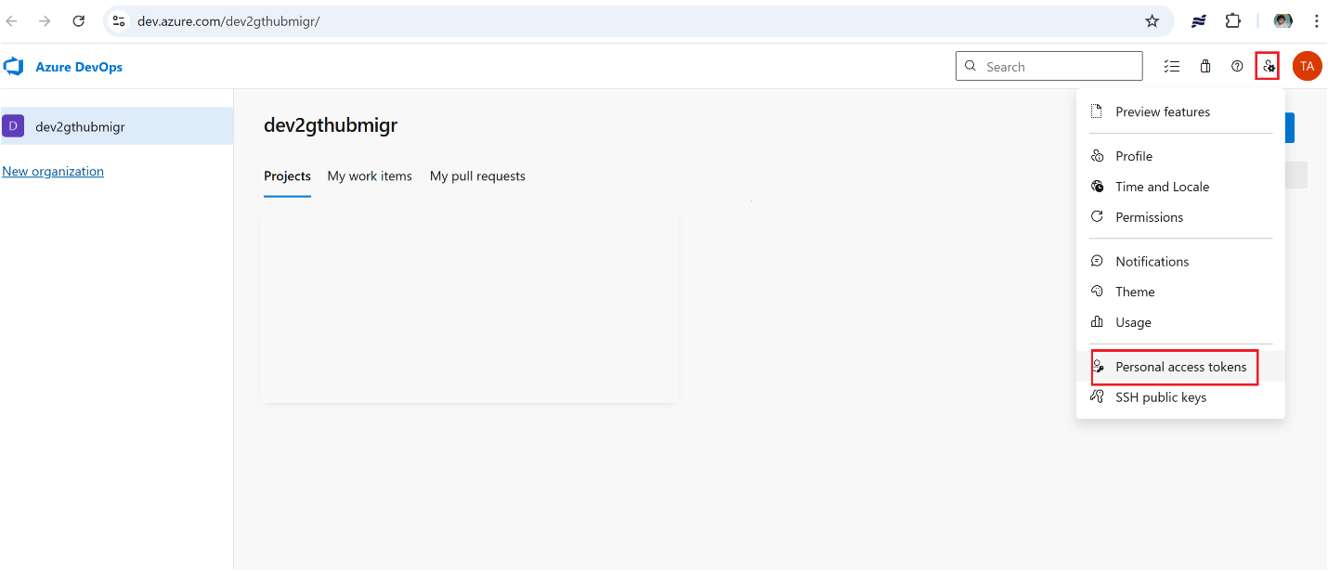

* 1. Select **+ New Token**

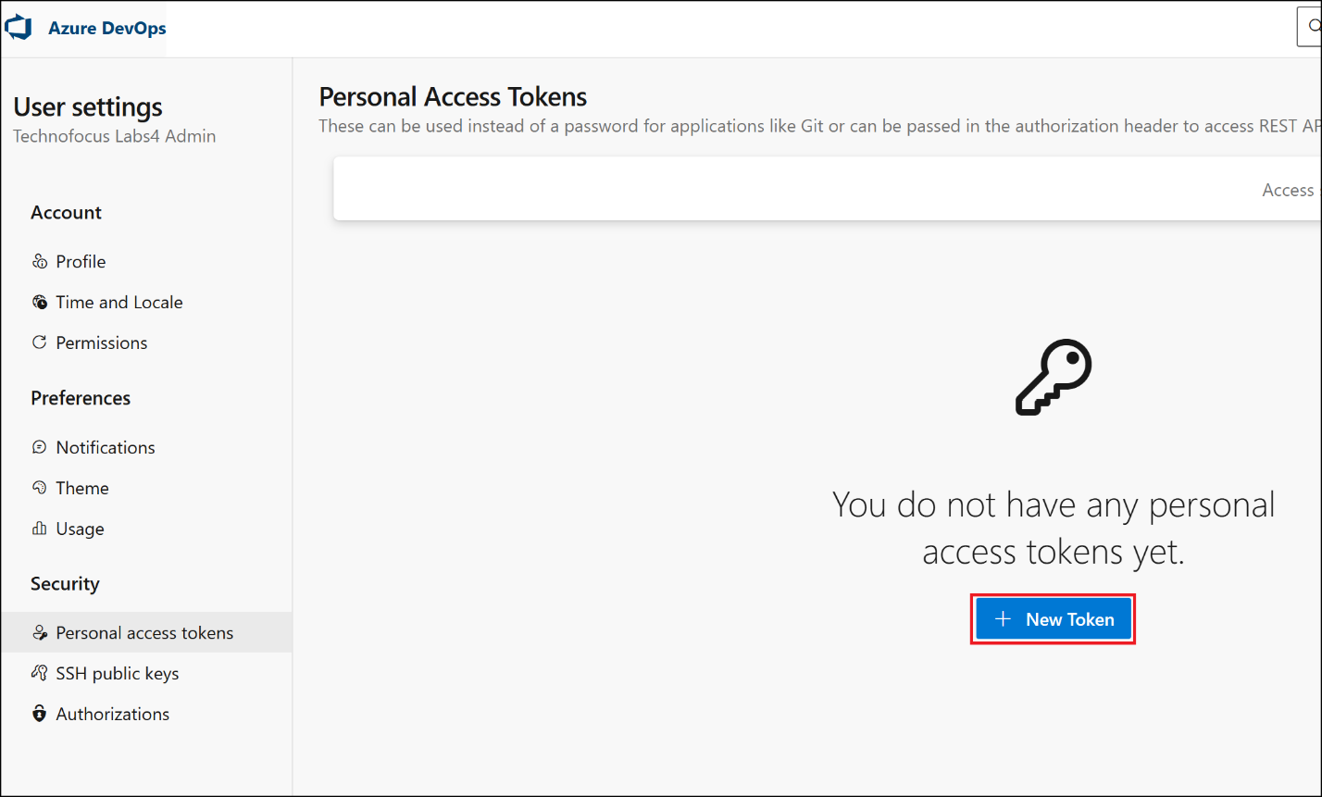

* 1. Enter the name as : **devopstoken** and select the following scopes (you may need to select Show all scopes at the bottom of the page to reveal all scopes):
     + Agents Pool: **Read & write**
     + Build: **Read & execute**
     + Code: **Full**
     + Deployment Groups : Read & manage
     + GitHub Connections: Read & manage
     + Pipeline Resources: Use and manage
     + Project and Team: **Read, write, & manage**
     + Pull Request Threads: Read & write
     + **Secure Files: Read, create, & manage**
     + Release: **Read, write, execute, & manage**
     + Service Connections: **Read, query, & manage**
     + Team Dashboard: Read & manage
     + Task Groups: **Read, create, & manage**
     + **Test Management: Read & write**
     + Variable Groups: **Read, create, & manage**
     + **Work Items: Read, write, & manage**

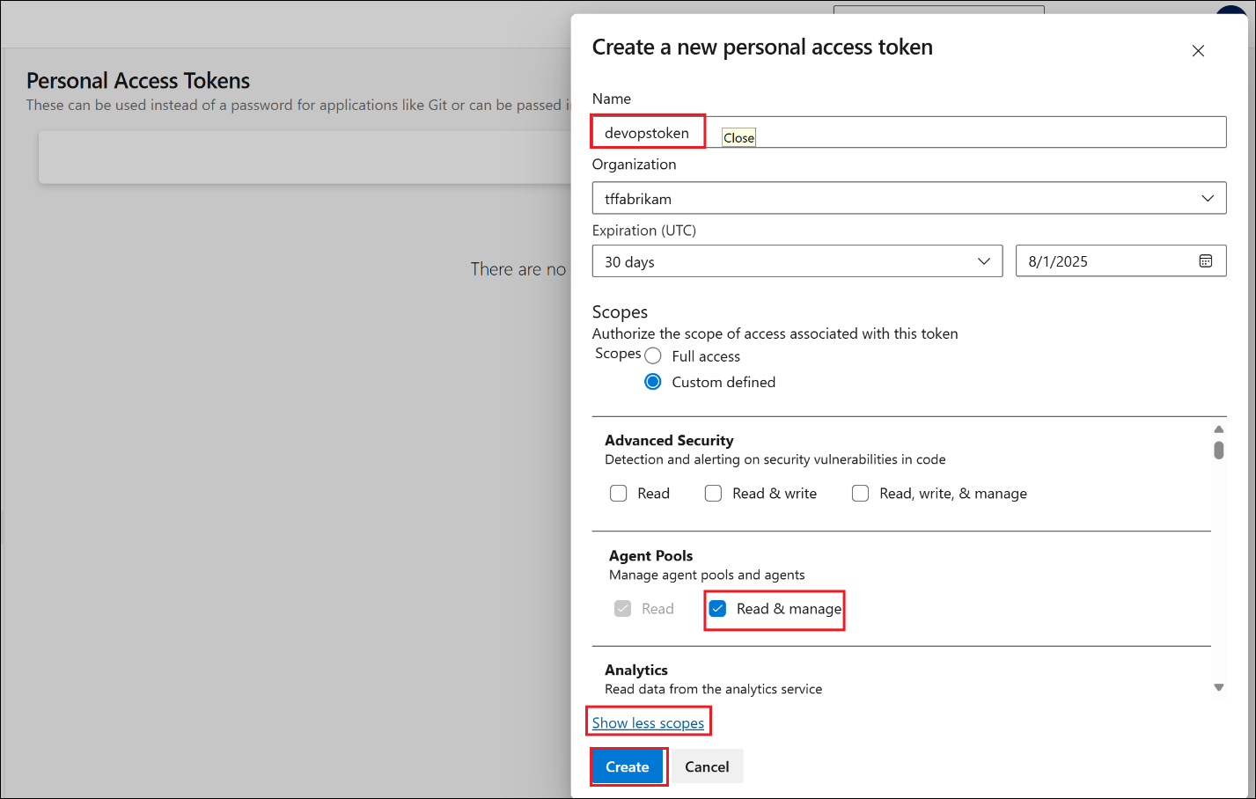

* 1. Copy the generated API token and save it in a safe location. For your security, it won't be shown again.

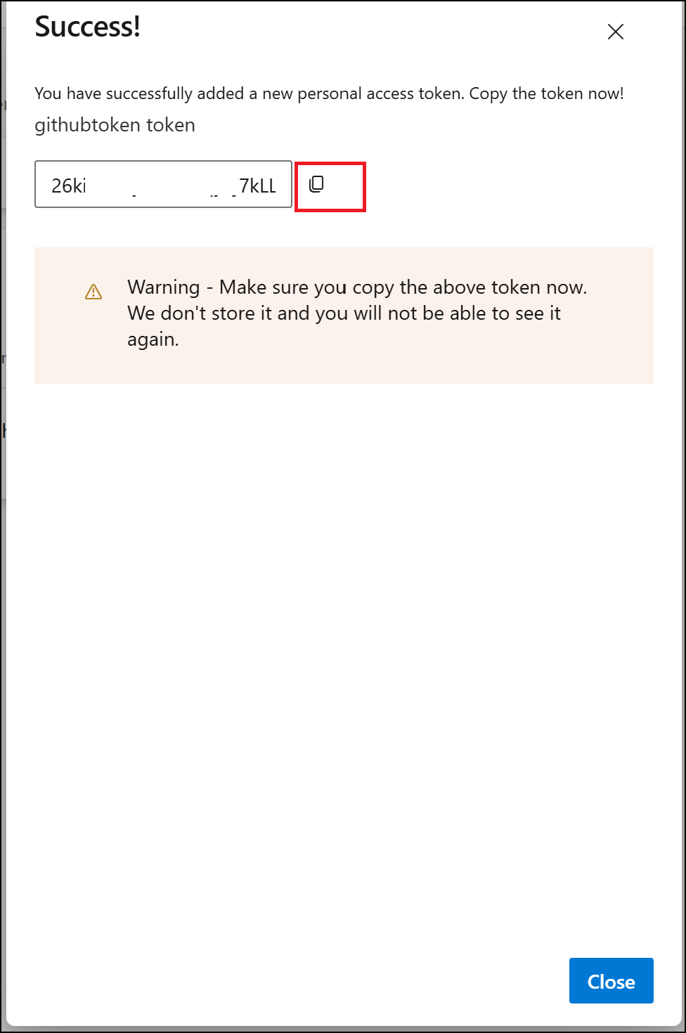

### Task 5 : Push Repo in Azure DevOps

1. **Open GitBash from Desktop and run below command to navigate to the project repo.**

**cd “C:\LabFiles\azure-search-openai-demo”**

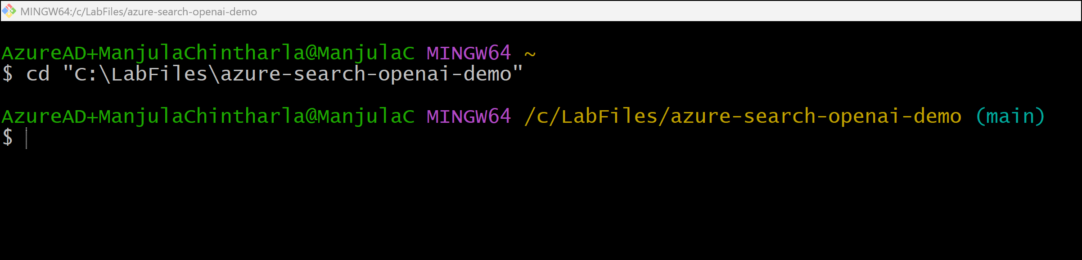

1. **Run below commands to push the repo.**

git init

git add .

git commit -m "Initial commit for migration lab"

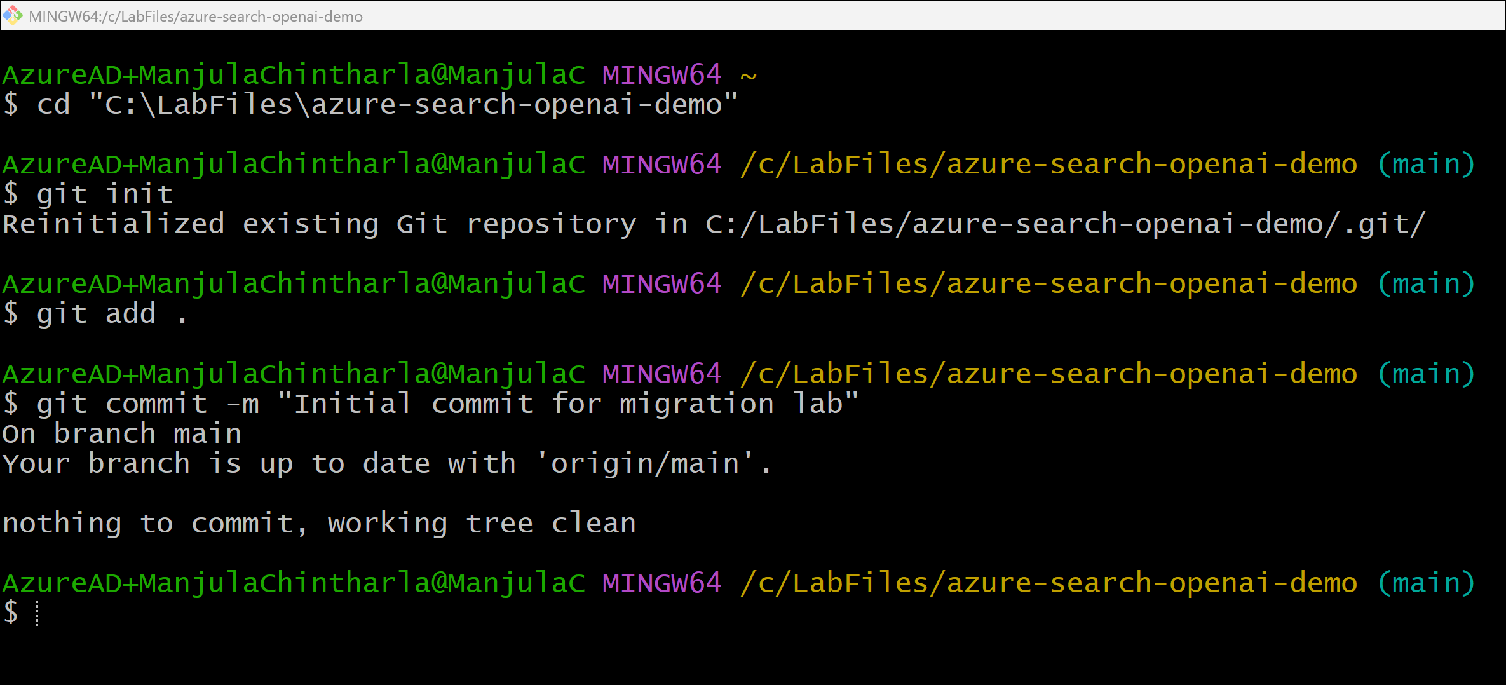

1. **Click on** Repos- > File **from left navigation menu.**

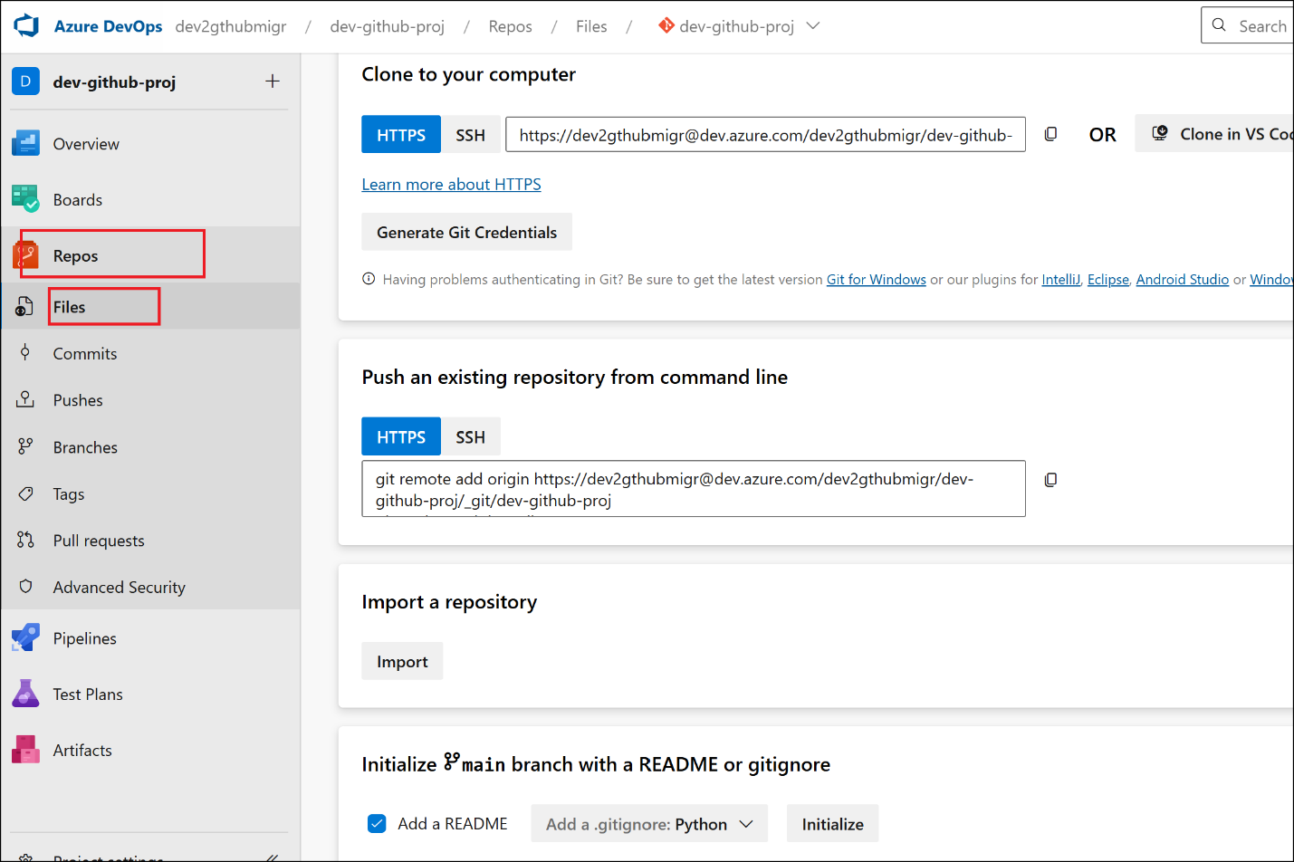

1. Under section **Initialize main branch with a README or gitignore** , select **Add a README** check box and **Python** from **Add a .gitignore** drop down and then click on **Initialize.**

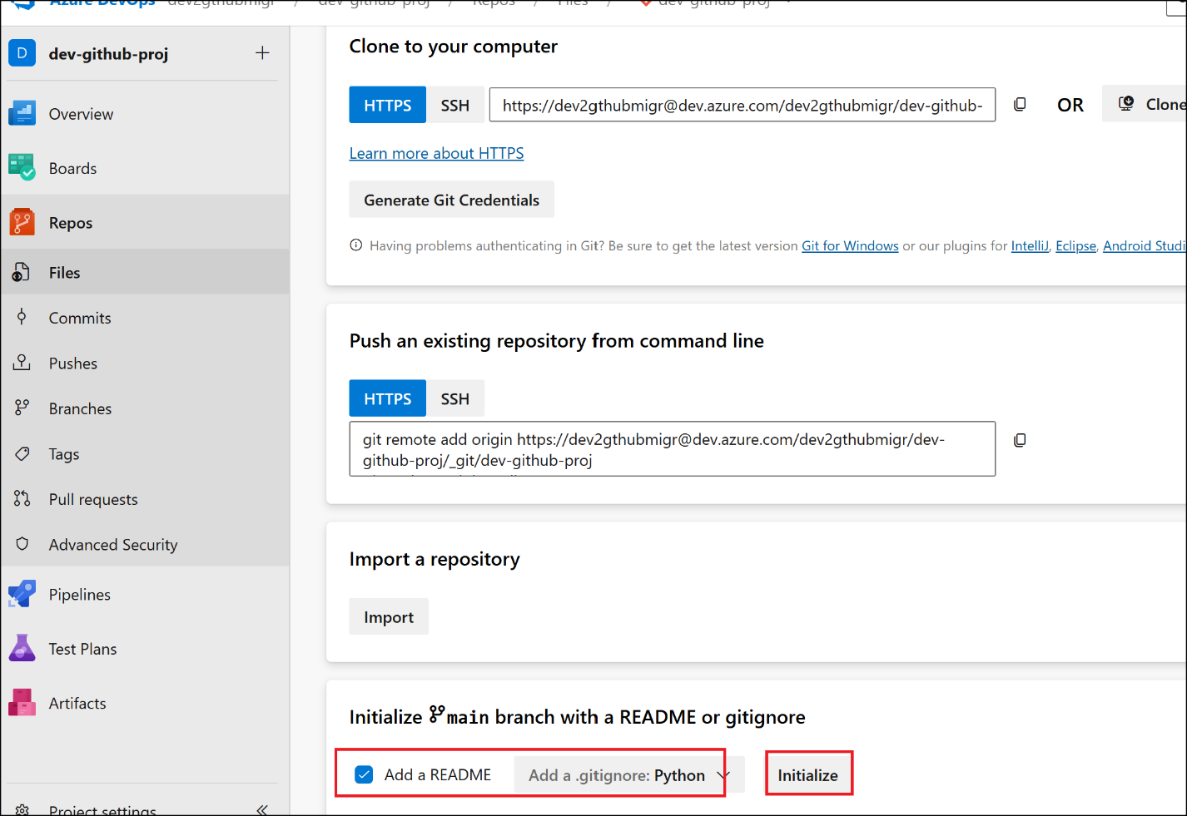

1. **Switch back to GitBash and run below command to sign into Azure. Sign in with your Azure subscription account.**

**az login**

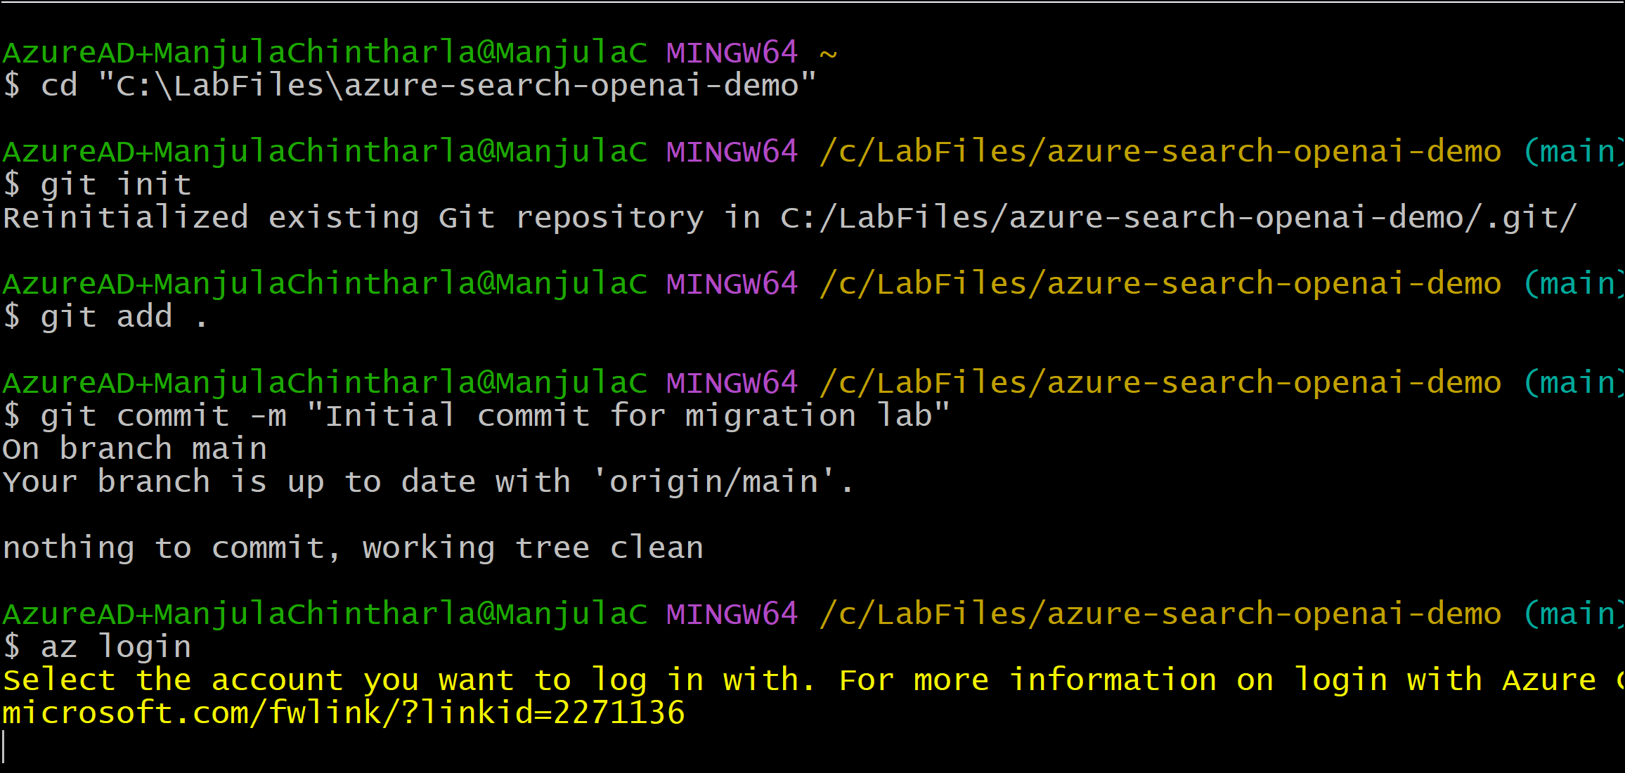

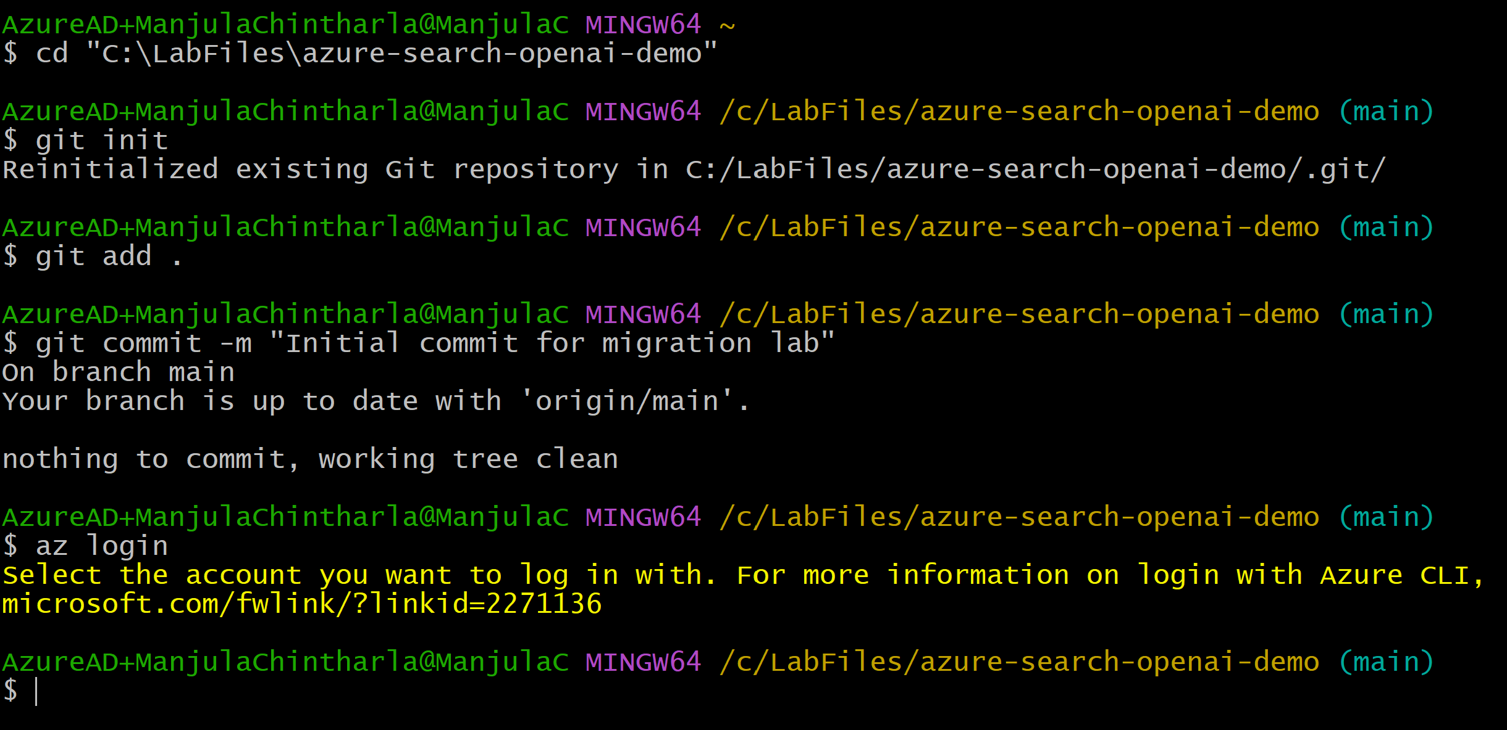

1. **Run below command to push local folder to Azure Devops .(Replace** [**https://dev.azure.com/dev2gthubmigr/dev-github-proj/_git/dev-github-proj**](https://dev.azure.com/dev2gthubmigr/dev-github-proj/_git/dev-github-proj) **with your org link )**

git remote add origin **https://dev.azure.com/dev2gthubmigr/dev-github-proj/_git/dev-github-proj**

**https://dev.azure.com/newdevorg123/newdev_proj/_git/dev-github-proj**

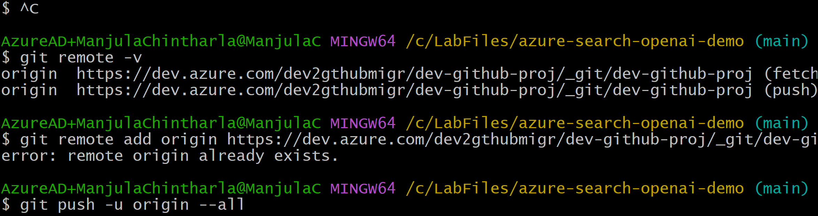

1. **Run below commands to pull remote repos.**

**git pull origin main --allow-unrelated-histories**

1. **Run below command to push the repo to Devops . it prompts you to sign in . sign in with your Devops account.**

git push -u origin --all

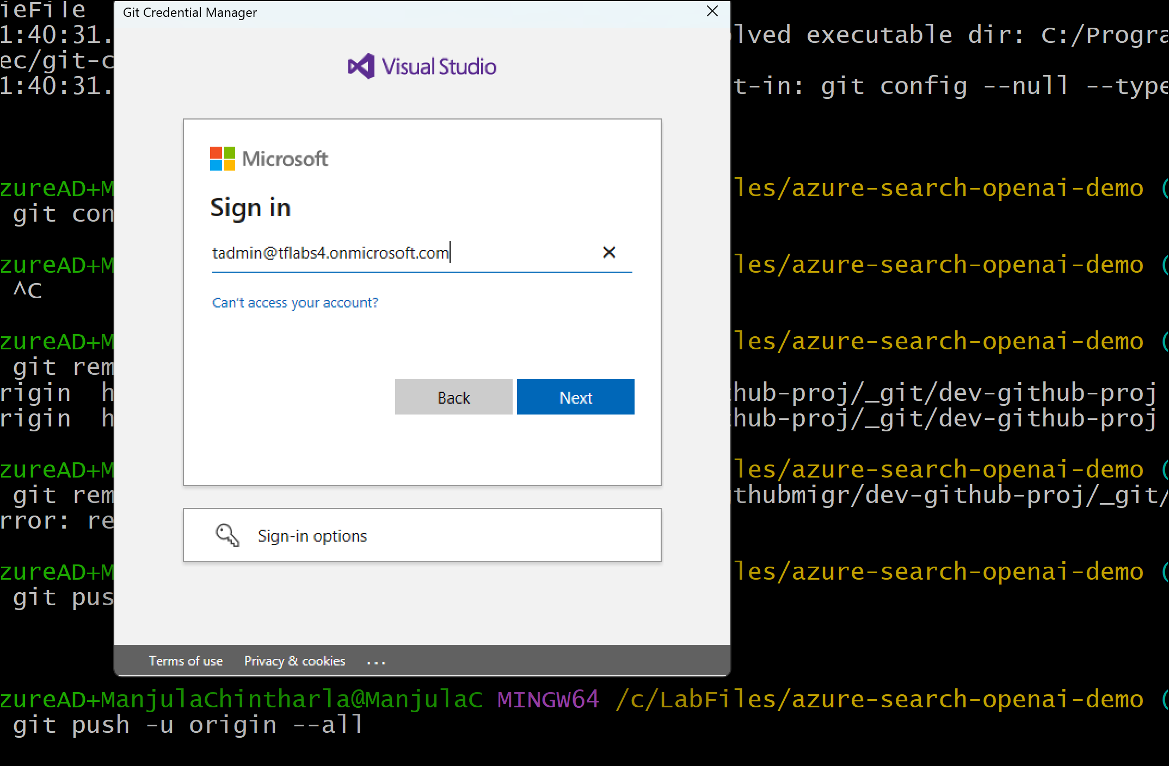

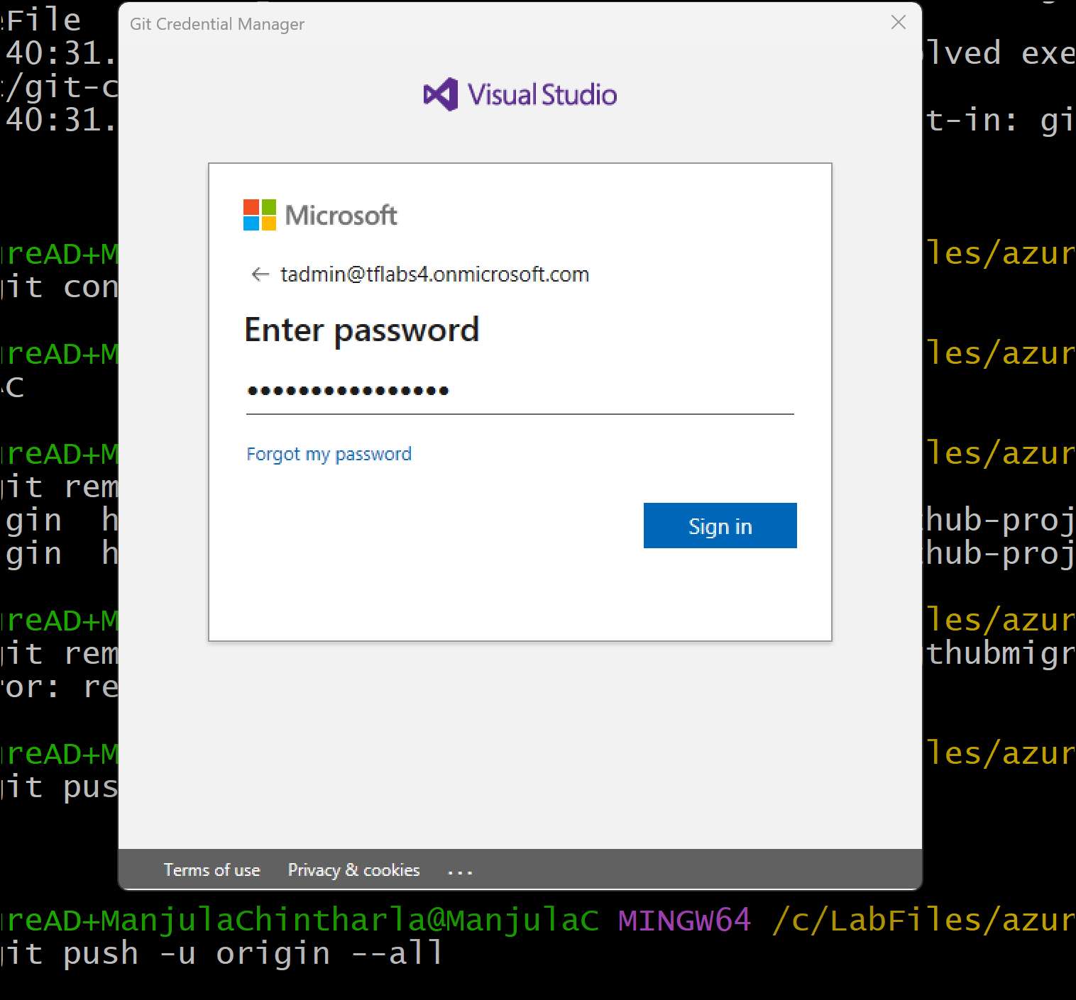

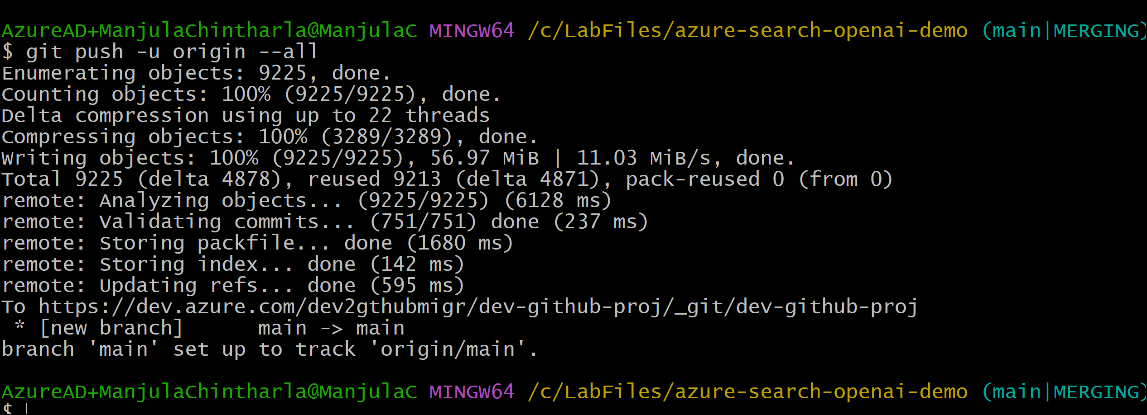

**Note : If you already have repo in Devops then follow steps to pull and resolve conflict – 1. Pull from DevOps with unrelated history:** **git pull origin main --allow-unrelated-histories Step 2 : Resolve conflicts in files like .gitignore, README.md. Step 3 : Stage the resolved files - git add .**

**git commit -m "Resolved merge conflicts"**

1. **Go back to Azure Devops project and check Repos-> Files .You should see your repo here .**

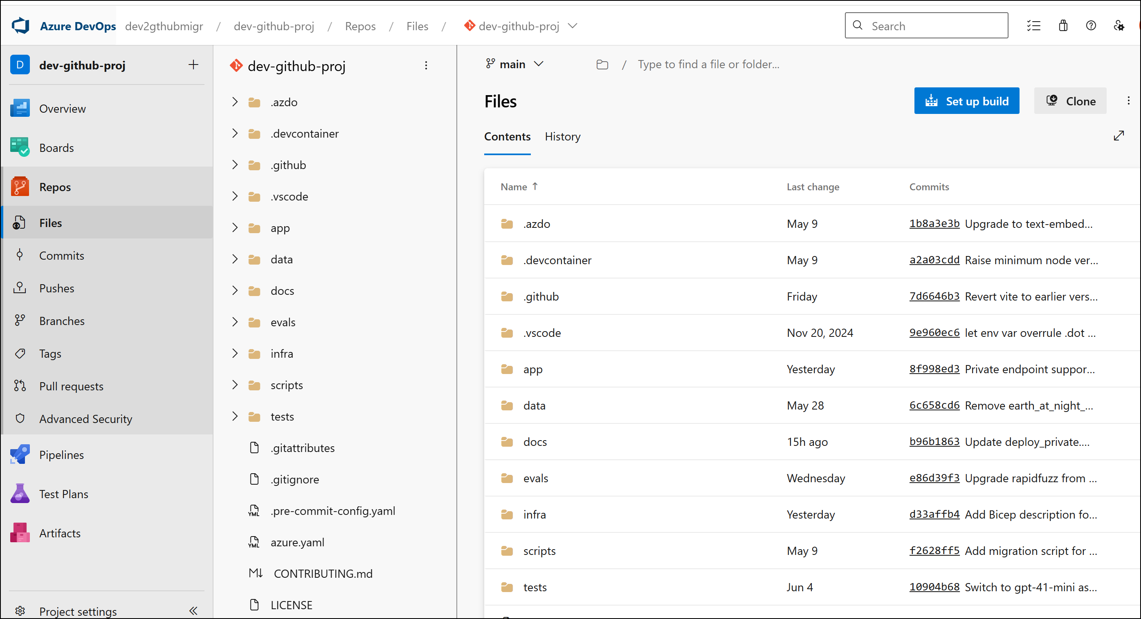

### Task 6: **Create a GitHub Personal Access Token (PAT)**

1. **Switch back to GitHub and click on Settings.**

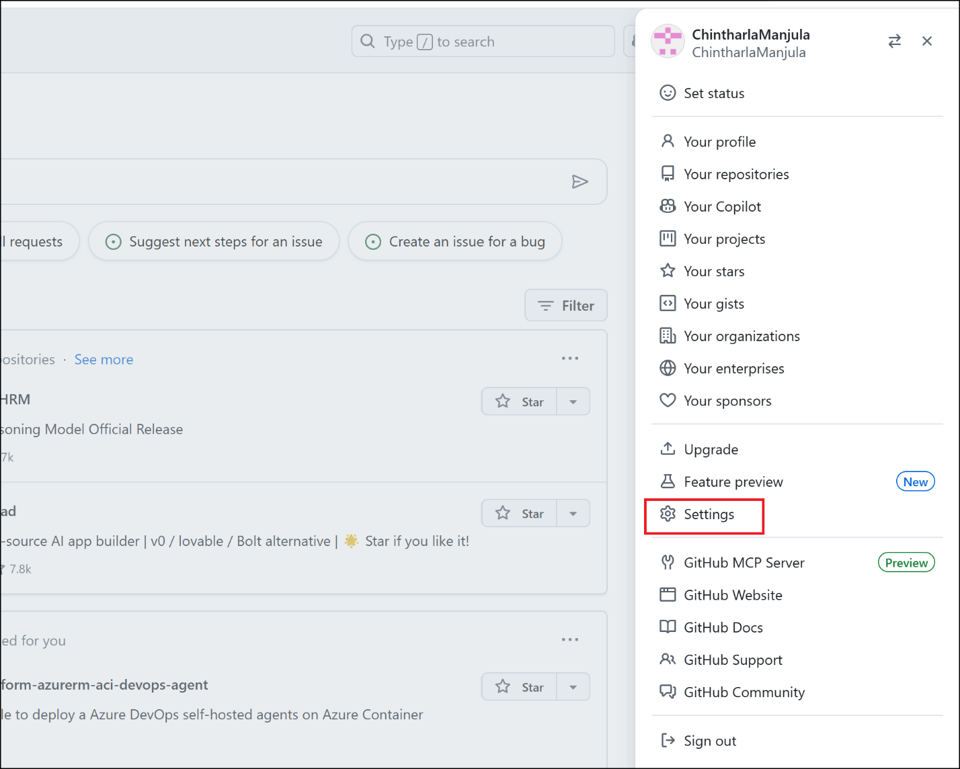

1. **Click on Developer Settings from left navigation menu.**

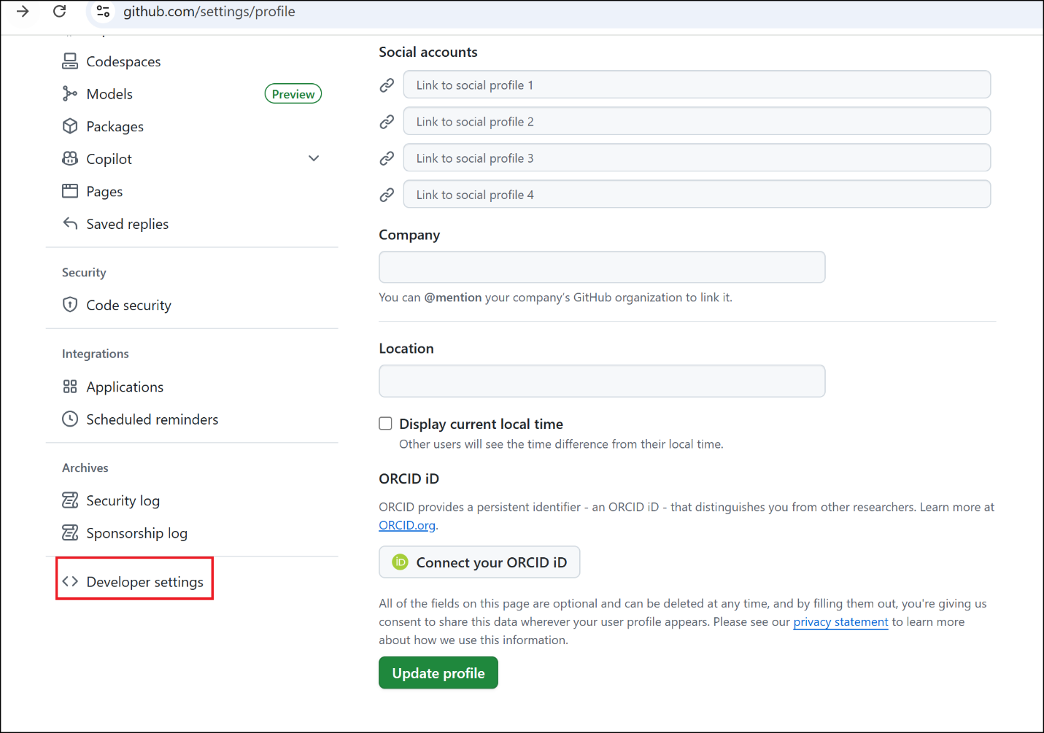

1. **Click on Personal Access Tokens->Tokens(classic)-> Generate new token(Classic)**

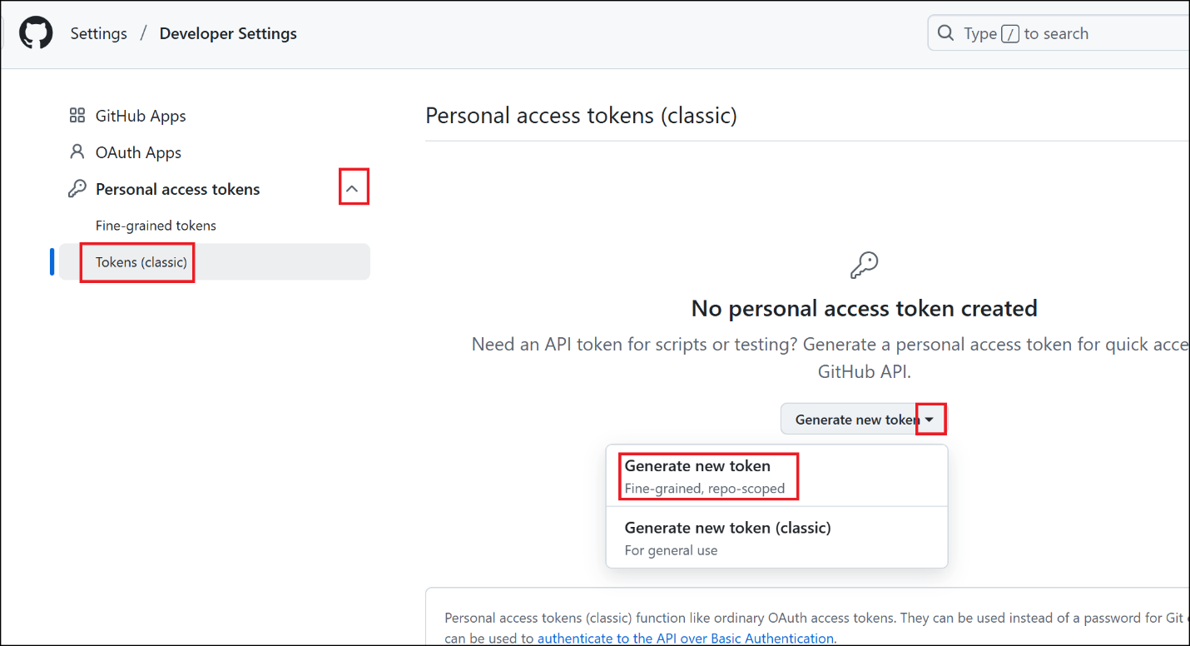

1. **Enter the token name -** **githubtoken-test and keep all default values .**
2. **Click on Generate token -> Generate token.**

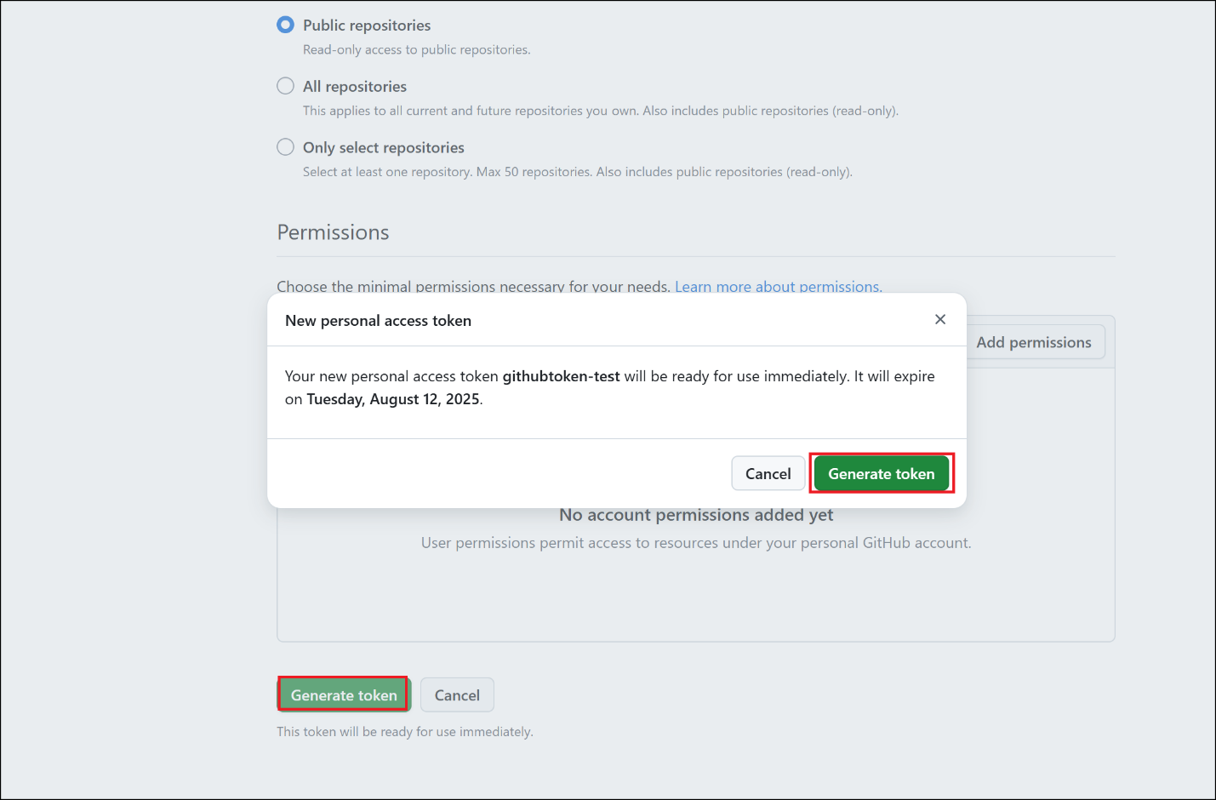

1. **Copy the token and save it in notepad to use in next tasks.**

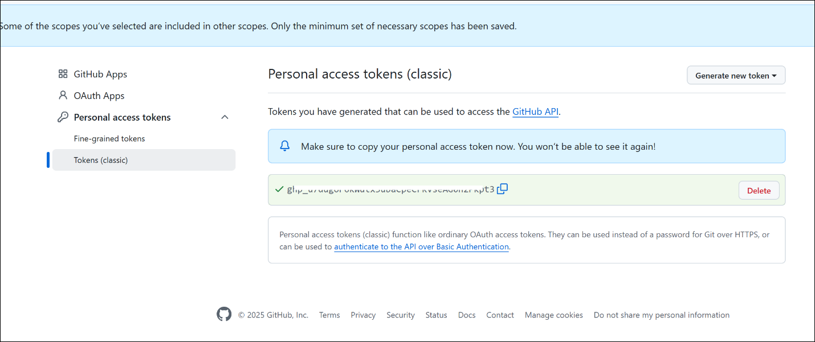

### Task 7 – Perform Migration

1. Switch back to GitBash. Run the following commands in your terminal (replace with your real tokens):

export GH_PAT=ghp_yourgithubpat

export AZURE_DEVOPS_PAT=youradopat

export AZURE_DEVOPS_source_ORG=yourdevopsorg

export AZURE_GITHUB_target_org=yourenterprisegithuborg

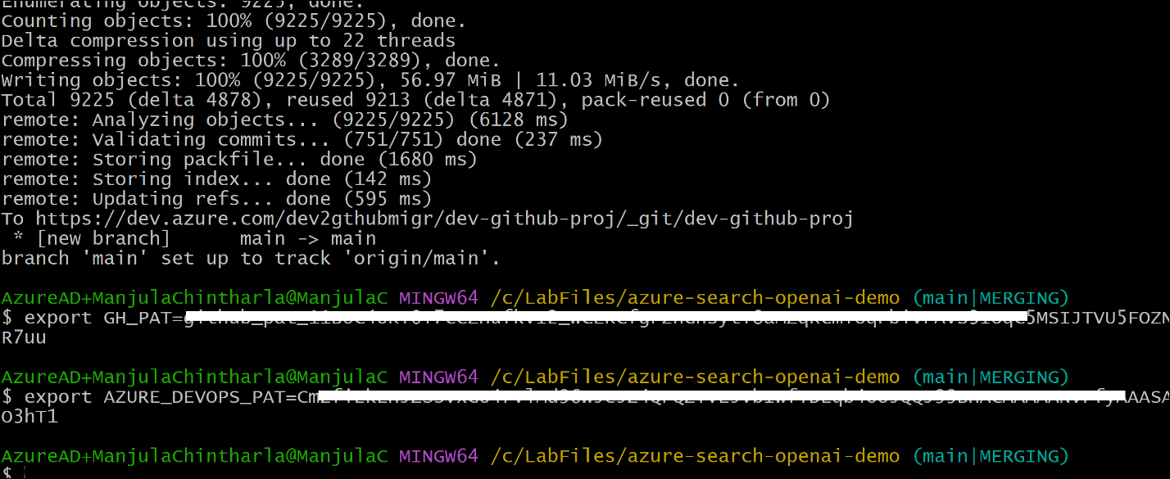

1. Run below command to provide migrator role

gh gei grant-migrator-role --github-org devopstogtihub --actor chintharlamanjula --actor-type USER

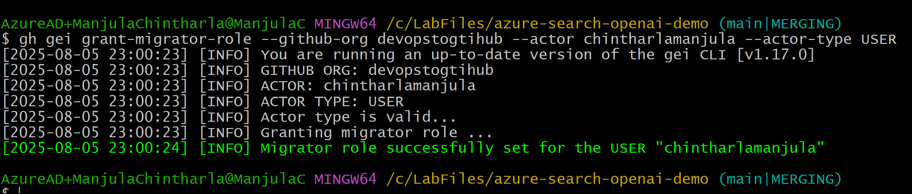

1. Install the ado2gh CLI Extension
2. Use the following command template to simulate the repo migration without copying data. You're telling GitHub Enterprise Importer (GEI) to **simulate** the migration, checking if everything is valid and ready to migrate — but **no actual repo, code, or history is transferred**.
3. Replace **dev2gthubmigr** with your Azure DevOps **org name** with your org url and run the command and devopstogithub-org- your GitHub **org name**

gh ado2gh migrate-repo --ado-org dev2gthubmigr --ado-team-project dev-github-proj --ado-repo dev-github-proj --github-org devopstogtihub --github-repo dev-github-proj-migrated-trial --ado-pat $AZURE_DEVOPS_PAT --github-pat $GH_PAT --queue-only

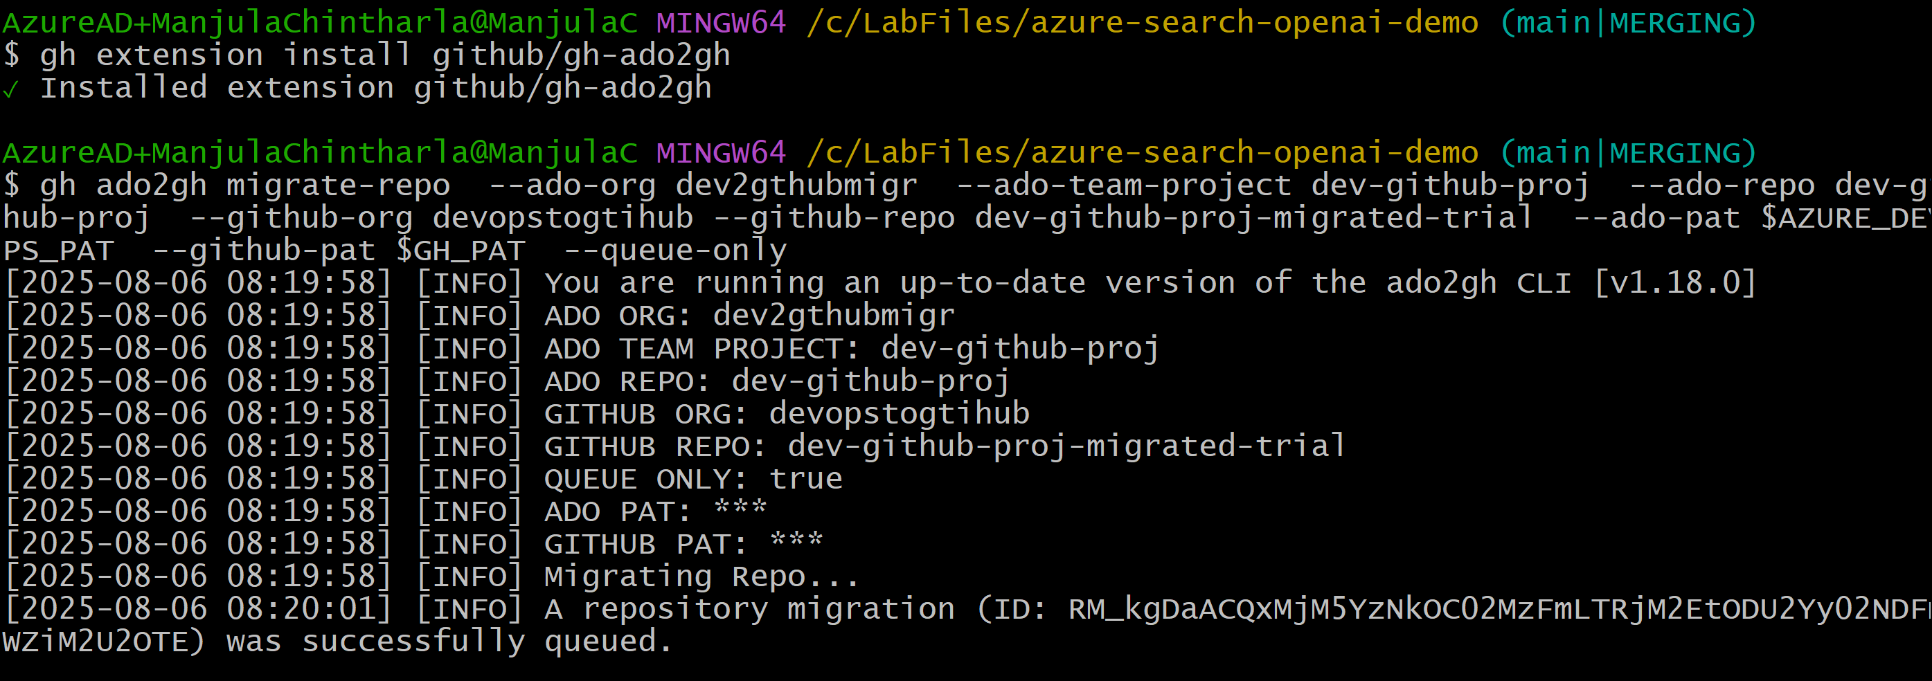

gh ado2gh wait-for-migration --migration-id RM_xxxxxx --github-pat $GH_PAT

gh ado2gh wait-for-migration --migration-id RM_kgDaACQxMjM5YzNkOC02MzFmLTRjM2EtODU2Yy02NDFmMWZiM2U2OTE

--github-pat $GH_PAT

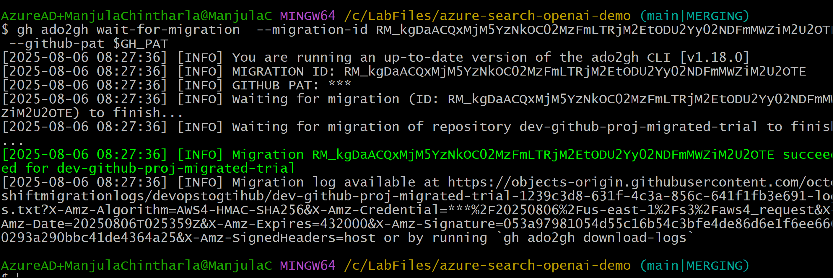

1. Switch back to Github GEC -> organization and you should see repo

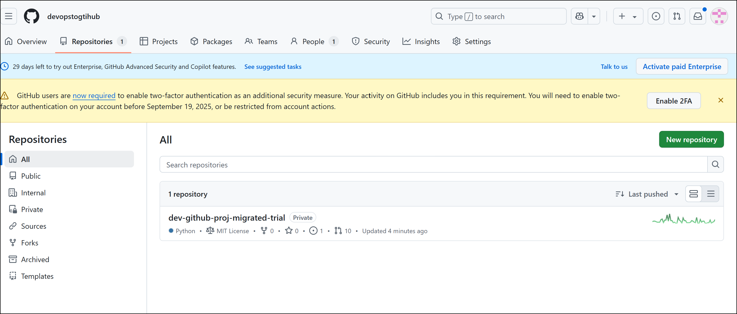

### Summary

In this lab, you performed a trial simulation of migrating a source code repository from Azure DevOps to GitHub Enterprise Cloud.  
You used the GitHub CLI along with the GitHub Enterprise Importer’s ado2gh extension to conduct a dry-run of the migration, ensuring the process completes without errors before actual migration.

This hands-on walkthrough enabled you to:

* Authenticate with both ADO and GEC using PATs
* Configure your source (ADO) and target (GEC) environments
* Run and monitor a trial migration to validate readiness
* Gain confidence in using GEI tooling for future production migrations